CHAPTER 1 INTRODUCTION TO THE STUDY

Background of the Study and Conceptual Framework

Stories of history and culture have been passed down through many generations through the art of oral and written storytelling. Philippine stories are rich in fictional folk narratives such as myths, legends, and folktales that shape history. However, the problem is that many of these stories are traditionally spoken but not recorded nor officially published as reading materials for the public. As a result, these stories rooted with deep historical meanings are slowly forgotten over time.

Since the 1930s, the introduction of a new literary genre called comic book began to emerge and grow for nearly decades as a subculture of literature, particularly in Western countries. It contains a series of images on panels to form a sequence to help guide the viewer throughout the story. Initially, comic books were most popularly known for the superheroes’ category, which was mainly designed to give entertainment for children.

Additionally, comic books are considered an alternate method of media consumption by offering engaging visuals at a low price, making it more affordable than other forms of literature at that time which was readily marketable for the younger audience. With the new and emerging technologies beginning to rise in all other parts of the world, the quality and innovative forms of comic books have improved, which allowed the comic book industry to grow beyond and achieve great success (Guffey, 2020).

Nowadays, digital and multimedia-based comic books are easily accessible on most electronic devices. Also, some comic books can have background music and animations, which add a unique touch and create immersion to connect the readers through the story. The amount of depth shown makes it evident that comic books are more than just a form of fictional literature. These stories can be explored within the academic setting by incorporating visual elements that are fun and easy to digest, making comic books an ideal learning material for readers.

Readers use visual literacy on a daily basis these days. New technologies have enabled everyone to create and share visual media by having the ability to interpret various illustrations and share the knowledge and culture of what they have learned from visual media. Hence, comic books can play a vital role in motivating readers and enabling them to develop comprehension and language skills in reading (Russell, 2019).

Through the internet, the rise of multimedia-based comic books has been made more convenient and accessible to advanced art and media-based software applications. This has opened up new opportunities and innovations for comic books to be more versatile and creative in telling captivating narratives.

In this study, a multimedia-based comic book provides readers with visual literacy in understanding the history and culture of traditional stories. Specifically, this capstone project focused on a popular legend that supposedly gave birth to the name of the island Guimaras.

Generally, this study aims to create a story adaptation based on the tale of Himal-us focusing on the Legend of Guima and Aras and to preserve the history of one of the legends told in Guimaras, Philippines.

Objectives of the Study

The researchers aimed to develop a multimedia-based comic book based on The Legend of *Guima* and *Aras*.

Specifically, it aimed to:

1. create a digital comic book with unique characters, background music, and stylized animations;

2. create a story adaptation based on the tale of Himal-us focusing on the story of Guima and Aras; and

3. evaluate the final output using usability evaluation.

Significance of the Study

This study aims to create a multimedia-based comic book on The Legend of Guima and Aras.

The results and output of this study would be beneficial to the following groups of people:

Children. This study would benefit the children by further developing their visual literacy to understand various visual media. Integrating a multimedia-based comic book would pave the way to shape and enhance their reading comprehension and retention of the information presented. Thus, they would understand The Legend of Guimaras with added entertainment.

Students. This study would help the students learn about the history and culture of Guimaras. Hence, it would promote the students' interest to delve deeper into the history of Guimaras and to understand the process of creating a multimedia-based comic book.

Teachers. This study would benefit the teachers because they can use the comic book as a reference to teach their students about the history and legend of Guimaras. Also, they can improve students' visual literacy and learn about the different visual forms of media.

Local community of Guimaras. This study would benefit the local community of Guimaras because this would serve as the first officially published multimedia comic book about The Legend of Guima and Aras. As the first detailed comic script, it would serve as their reference for imitating characters, behavior, arts, culture, and tradition of the characters, settings, and events presented.

Artists. This study would benefit artists because it would serve as their reference material for their artworks. Additionally, it could inspire artists when creating multimedia artworks, thus enhancing their creative and innovative skills in digital art.

Governmental and Non-governmental Organizations. This study would benefit the government and non-governmental organizations for the promotion and preservation of the history, culture, and arts of Guimaras both in local and international setting.

Future Researchers. This study would make future researchers aware of the legend of Guimaras and of the whole process of creating a multimedia-based comic book. Also, this would serve as a reference for their future research related to this study.

Definition of Terms

For better understanding, the following terms were defined conceptually and operationally:

*Audacity* – It is a free, open-source audio editing and recording software available in Windows, Mac, and Linux operating systems to compose, record, and produce audio and music used by musicians, scientists, podcasters, foley artists, and narrators (Beal, 2021).

In this study, the term refers to the software used by the researchers to record and edit audio recordings in music production for the comic book.

*Clip Studio Paint* – It is a digital graphic software used for the digital art creation of comics, illustrations, and 2D animations (Serra, 2021).

In this study, the term refers to the software used by the researchers to digitally create the character designs, storyboard, and illustrations for the comic book.

*Comic Book* – It is also known as a comic magazine with a narrative medium that tells meaningful stories by combining images usually printed in a magazine or newspaper (Pedri, 2022).

In this study, the term refers to the medium used by the researchers to create a story adaptation of The Legend of Guima and Aras in a vertically scrolling format.

*GitHub* – It is an online platform that was used for software development with features such as storing, managing, and collaborating on open-source projects (Juviler, 2022).

In this study, the term refers to the platform used by the researchers to streamline collaboration and ensure a systematic approach to code management. It allows to store, share, and track changes to the codebase.

*Himal-us* -It was derived from the Tagalog word “paghimud-us,” meaning a struggle for survival. Guimaras was formerly called “Himal-us” but eventually adopted the name “Guimaras” in the early part of the Spanish regime (Department of Environment and Natural Resources, 2019).

In this study, the termrefers to the name of the island used as a location in The Legend of Guima and Aras in the comic book.

*Krita – It* is a free, open-source digital art program for Windows, macOS, and Linux, *i*nitially released in 2005. The software is used to create digital illustrations and 2D animations. It includes a large library of brushes and other tools for creating raster graphics and animations (Computer Hope, 2019).

In this study, the term refers to the software used by the researchers to create 2D animated panels for the comic book.

*Legend* – It is a story not verified with evidence passed down by tradition from earlier times and is popularly accepted as something historical (Dictionary.com, n.d.).

In this study, *the term* refers to the folktale called The Legend of Guima and Aras, which the locals accept as the historical name origin of Guimaras island.

*LMMS* – It is a free Digital Working Station or DAW used to generate sounds, edit the beat and bass, and offer a MIDI control system to effortlessly design, compose songs, and create soundtracks (LMMS, 2022).

In this study, *the acronym* refers to the software used by the researchers to create the background music and sound effects to be added to the comic book.

*Multimedia* – It is a method for presenting ideas in communication, entertainment, or art by integrating multiple forms of media such as sound, video, and text (Merriam-Webster, n.d.).

In this study, *the term* refers to the media disciplines such as text, sound, animation, and images used by the researchers in making the comic book.

*Netlify –* It is a developer-oriented all-in-one serverless platform that combines building, deployment, hosting, and a CDN into a single service (Williams, 2022).

In this study, the term refers to the platform used by the researchers to deploy and host the website.

*Visual Studio Code* – It is a free source code editor software that can run on desktop computers and the web. It is available in multiple Operating Systems such as Windows, macOS, Linux, and Raspberry Pi OS (Heller, 2002).

In this study, the termrefers to the code editor software used by the researchers to write the code for the website creation of the comic book using HTML, CSS, and JavaScript.

*WriterDuet* – It is a digital writing software used for making screenplays or scripts. It includes features such as real-time collaboration, the option to do online and offline editing, and a user-friendly interface (Industrial Scripts, 2019).

In this study, the termrefers to the software used by the researchers to write the script for the comic book.

Delimitation of the Study

This study focused on creating a multimedia-based comic book with a story adaptation of one of the legends from Guimaras island called, The Legend of Guima and Aras.

The researchers used various digital software applications such as WriterDuet for the script writing process; Clip Studio Paint for character designs, storyboarding, paneling, and illustrations; Krita for the 2D animated panels; LMMS and Audacity for audio mixing; Visual Studio Code for designing and programming the website for viewing the comic book; and GitHub for uploading and publishing the comic book online.

This study used a vertical scrolling comic book format for a continuous smooth flow of visual storytelling, the option to toggle the background music on and off, and to have short-animated scenes on selected parts of the story.

The comic book is limited to online viewing which requires internet access to view the website. It cannot be downloaded or accessed offline.

This study was conducted on sixty-nine (69) participants with forty-one (45) participants from Guimaras and twenty-three (24) participants outside of Guimaras. A descriptive type of research was used in this study. To get the data needed, the researchers conducted an online survey through the use of Google Forms, a web-based online service for creating and taking surveys, collecting data, or presenting lists (Yunita, 2019).

CHAPTER 2 REVIEW OF RELATED STUDIES

Review of Existing and Related Studies

The literature and studies related to this study are reviewed in this chapter. This includes four (4) parts: (1) The Historical Background of the name Guimaras, (2) The Legend of Guima and Aras, (3) Concept of Digital and Multimedia Based Comic Books, (4) Improving Literacy using Comic Books, and (5) Related Studies.

Part One, The Historical Background of the name Guimaras, describes the origins and the meaning behind the name Guimaras Island, Philippines.

Part Two, The Legend of Guima and Aras, tells the popular legend widely believed and told by the local people in Guimaras.

Part Three, Concept of Digital and Multimedia Comic Books, introduces the digitization of conventional comic books into digital comic books with multimedia features.

Part Four, Improving Literacy using Comic Books, reviews the relevance and its impact in improving the digital literacy skills of readers.

Part Five, Related Studies, reviews existing research related to the development of this study.

The Historical Background of the name Guimaras

Fr. Fernandez (1987) wrote the historical annotation of the island of Panay, which included Guimaras as one of the towns of Panay Island in Visayas, Philippines. The description of Guimaras contains the history wherein upon the first few days of the Spaniard's arrival in Guimaras island, Christianity was established and called the island “Himal-us.”

However, in an excerpt entitled “Historical Facts and Figures of the Municipality of Jordan Guimaras,” Himal-us is the original name of the whole island of Guimaras but was later changed to *Nagaba* due to a popular legend of two lovers whose parents are opposed to their relationship and the ending was that they were “*nagabaan*” or accused of their ill-fated love. The island’s name was officially changed to Guimaras in the last few days of Spanish domination.

Another excerpt by Garganera M. (1996, as cited in Galindo, n.d.) states that the Himal-us is the former name of Guimaras. The account states that it originated from the narration of the late octogenarian Eusebio Gemudiano, a Spanish official of Barangay Sinapsapan. He narrated that he wandered, looked across Iloilo Strait, and asked the first native person he met about the island's name. The Iraya native replied in *Kinaray-a*, saying “*Himal-i ko*,” which translates to “How would I know?” in English. However, the pronunciation was unclear, and it sounded like “Himal-us” to the foreigner. Furthermore, the account mentioned a theory that Himal-us was changed to the name Guimaras as an acronym of Guimbal and Igbaras, combining the first four letters “GUIM” of Guimbal and the last four letters of “ARAS” of Igbaras. Other earlier accounts pointed out that the name Guimaras was in honor of two ill-fated lovers named Guima and Aras, whom both escaped from the wrath of the former’s father as they sailed on to the sea, which later that night came to a storm and they both passed away.

The Legend of Guima and Aras

An excerpt from Garganera, R. (2021) contains the trilogy about the legend of Guimaras known to come from the tragic love story of the couple Guima and Aras. This story aims to conserve the legacy and culture of Guimaras and educate the island's visitors.

The legend focuses on three main themes: the desire of man to be free, the preservation of one’s customs and traditions, and safeguarding the Hiligaynon dialect.

The story is divided into three parts:

Part I is “The Flight from Boracay (Borneo, today’s Malaysia).” It told the story of the Malay settlers fleeing from their current sultan's evil clutches and landing on the Sirawagan River, currently known as San Joaquin.

Part II is “Marikudo and the Barter of Panay”. The Malays found the Aeta tribe, who were hiding from the Moros. The settlers sent an emissary who made a friendly pact between them. However, they soon parted ways and lived separately on their own.

Part III is “Guima-Aras, A Love Story, An Island, the Legend.” This starts the story of a couple between two different tribes, and this is how the legend of Guimaras came to be.

Concept of Digital and Multimedia Based Comic Books

In recent years, the digital era has been present in every aspect of our lives, and our reading experience also changes daily. Today, readers are not only reading printed pages but many types of books that are now available on many electronic devices such as smartphones, laptops, and computers. Readers rely more on these devices to access many kinds of books digitally. Comics also evolved from traditional printed comics in magazines and newspapers to digital forms.

Kirchoff (2017) explained the three categories of digital comics: remediated comics, ergodic-hypercomics, and multimedia comics. In the multimedia comics category, these comics can have additional modes of communication to the traditional printed comics of images and text. Multimedia comics can include sound (e.g., background music, spoken dialogue or narration, sound effects), motion, interactive puzzle games, and background video (e.g., an image of a TV screen playing a video in the background). Multimedia comics may be hyperlinked, giving readers more information about the comic.

As studied by Maity (2022), readers enjoy reading comics the best when the genre includes multimedia. Readers can enjoy many forms of digital comics such as webcomics, web manhua, webtoons, motion comics, and many more.

Webcomics refer to comics exclusively published on websites that are usually updated every week. Manhwa is generally known as printed comics and cartoons made in South Korea, and they also developed its digital version of manhwa with webtoons titles. The term webtoon came from two words website and cartoon, and webtoons managed to surpass its printed forms. In recent times, the features of the webtoons format enable readers to enjoy making it different from any other comic format. Traditional comics are usually published in horizontal comic strips, while webtoons use vertical strips with no pages to flip. Thus, readers can enjoy reading stories by just scrolling up and down on a smartphone or tablet, which is more convenient for the reader. Webtoon creators can include multimedia such as sound and animation in manhwa for a more entertaining experience. Webtoons are usually published with colored art instead of the typical black and white (Maity, 2022).

Moreover, Karlimah et al. (2021) defined motion comics as digital comics that allow characters to move on each page. They also stated that it is crucial to establish the visual mood to provide the final output's initial scene, which can then be designed into sequential images. The storyboard transformed the animation design into a moving image in the pre-production process, and the final output was polished using an animation application.

Adding music to a comic book can provide an additional form of entertainment and make storytelling much more immersive to the reader.

Blin-Rolland (2019) proposed the concept of ‘resonance’ as the process through which audio-visual elements interrelate that is triggered through media dissemination or ‘dissemediation’ and the opportunity of combining sound and image to transform into something new and dynamic. He calls it music-comics or ‘musicomic.’ He explained that “as the reader-listener is called upon to synchronize sound and image in song chapters that combine a track of several minutes and a comic of a few pages, this may considerably slow down the reading process” (p. 14). Rather than forcing the readers to keep up with the music and story simultaneously, the readers should take their time lingering over the image and engross the messages of the musicomic both visually and aurally. This approach in viewing both the comic and music anew through dissemediation allows the readers to explore it more deeply.

Improving Literacy using Comic Books

A recent study by Nurharini et al. (2022) looked into the problem of students who are technologically literate but are having difficulty taking advantage of technology for valuable things. The students were not interested in learning science media, and their school had no effective teaching materials to guide them. This prompted the researchers to develop a portable online and offline animated comic that can be accessed on mobile devices and computers. The animated comic is done through online learning. Their study showed that students could improve their scientific literacy skills using portable animated comic learning media compared to regular illustrated comics without animation. The development of portable comics makes it easier for students to study independently anywhere at any time.

Another study by Rina et al. (2020) observed that a teacher was having problems teaching students with merely used textbooks and noticed that students are more visual learners and it would be easier for them to understand lessons when exploring new media. The researchers then developed a digital comic media with music effects on human relations and the environment. It makes it easier for students to fully comprehend images, build their imagination, explain meaningful ideas, and tell the story's content more coherently. They argued that printed comics have many more setbacks, such as the durability of paper may not last long and format limitations. In contrast, digital comics can be stored digitally and has a flexible layout. The study results showed that all aspects of the digital comic book had a “very good” rating. It has been proven effective in increasing students' character of discipline and responsibility.

Related Studies

Nowadays, comics are popular and loved by children and people of all ages who appreciate them. As the present era of digitization increases worldwide, so does the need to digitize our cultural heritage. Here is where the position of comics plays an essential role as it gives a graphical representation and view of society and culture. Despite multimedia currently being a popular concept in the global scheme, it struggles to gain recognition such as music, literature, and films in other countries like India. To push more community engagement of avid comic readers and increase its popularity everywhere, Gupta (2021) conducted a study that attempted to make an interactive multimedia-based comic book with audio, subtitles, animation, and background music through visual computing with the given digitized Indian comic. Deep learning techniques were also used to part comic book elements such as improving panels, text balloon segmentation, text recognition, comic character detection, and panel text ambiance analysis to enhance the overall story. Gupta’s comic book can also be used in augmented reality technologies, where the extracted comic book elements can be used to develop an AR application.

Furthermore, at the start of the 21st century, the rise of the internet and the proliferation of computers gave way to the concept of digital space, which allows the growth opportunities of integrating multimedia and new interactions for comics. However, the problem is that most comics still need to maintain their conventional printed formats. With this, the goal of Stenberg’s (2020) study is to integrate both the practice of interactive design and digital comics. The results show that the comics format did not change much when it made its way to the digital space, which means that the comics format is already suitable on its own. However, Stenberg concluded that interaction design methods could be used when designing an interactive digital comic book such as scrolling and zooming hand gestures which can improve the reading experience.

CHAPTER 3 RESEARCH DESIGN AND METHODOLOGY

Description of the Proposed Study

This study focused on creating a digital comic book and a website to upload the digital comic book which contains animation and sound to enhance the viewer’s experience and immersion. A digital comic book was produced and publicly published by the proponents. It was designed to be compatible with either a smartphone, tablet, or computer device. WriterDuet was used in writing the comic script; Clip Studio Paint was utilized to create the comic; Visual Studio Code was used for the coding of the customized website where the comic was published; and LMMS and Audacity for the different audio mixing and editing sound and music. Upon opening the website, the user was introduced to three different webpages such as the homepage, comic webpage, and asset webpage. The homepage includes a hero page, foreword, meet the team, and mission. The comic webpage includes sixty-four (64) comic pages. The asset webpage includes character designs, illustrations, storyboard, and photo references.

Methods and Proposed Enhancements

Multimedia based comic books uniquely combined illustrations, text, music, and animation as an effective medium to foster generative learning. As discussed in the related literature, it significantly improves one’s literacy skills in comprehending visual media.

This study would serve as an informative yet entertaining digital piece of literature that allows readers to learn about the Guimaras folktale called “The Legend of Guima and Aras. A multimedia-based comic book was developed for online digital distribution. The comic book included a set number of pages in 800 x 1920 pixels canvas size as the standard webtoon format template.

Through website integration, users can access the comic book online and scroll vertically to view the comic illustrations and 2D animations. The user can also scroll through the page navigation slider to find a specific page to view. The option to toggle music on and off as well as a zoom feature is added to the website. When the user opens the comic webpage, a mini tutorial would help the user guide through the buttons and instructions on how to read the comic book with ease.

Components and Design

*Character Design*

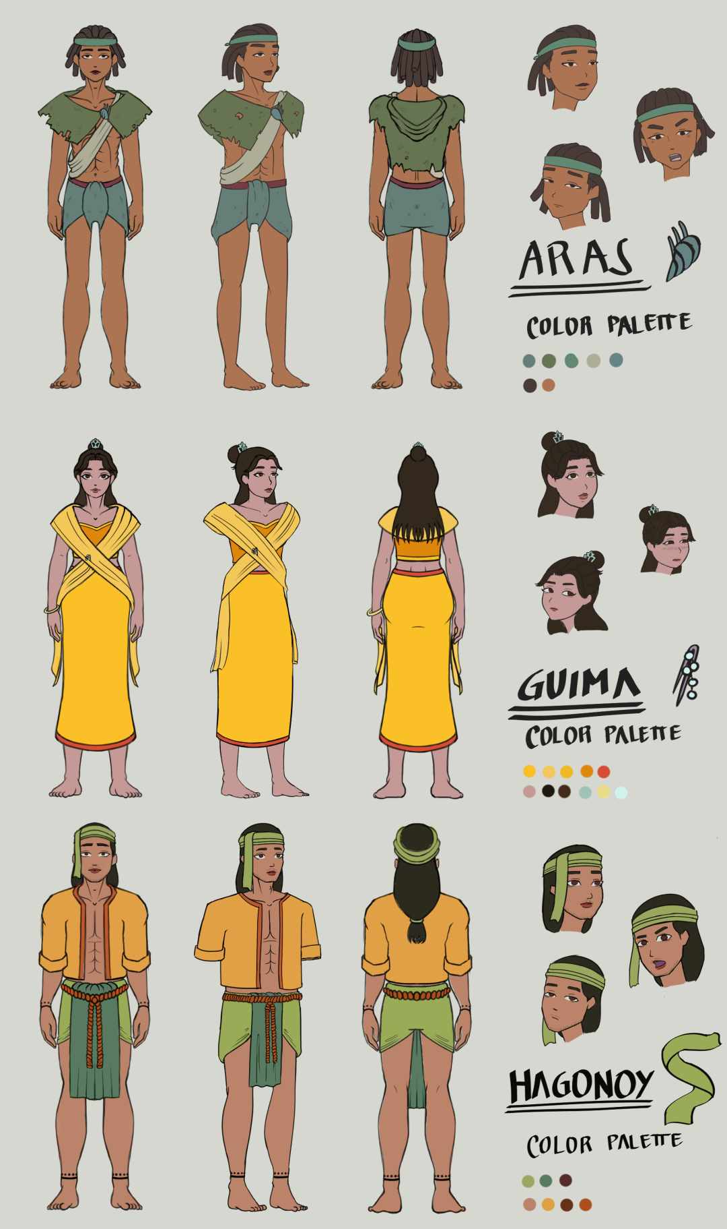

**Figure 1.** Character Designs of Guima, Aras, and Hagonoy

As shown in Figure 1, the main characters were illustrated in a turnaround model sheet that served as a reference for the characters to be illustrated in the comic book. The design and relevance of the character play a significant role in capturing the reader’s first impression. It provides an intriguing learning experience in the process of visual reading. The character illustrations were made in Clip Studio Paint with a Graphics Tablet during the pre-production stage.

Storyboard

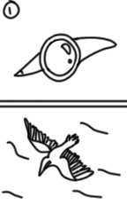 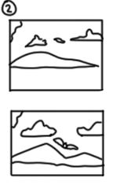 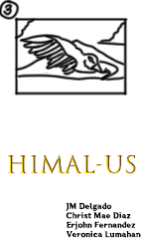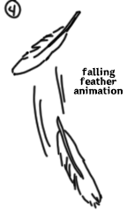 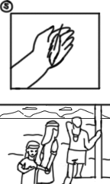 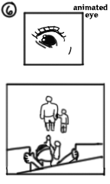

**Figure 2.** Sample Storyboard

As shown in Figure 2, the storyboard was illustrated with a sequence of 2D illustrated scenes and shots based on the script for pre-visualizing multimedia-based comic book illustrations. Clip Studio Paint was used in the making of the storyboard. The storyboard contains rough sketches of the entire story, character placements, background locations, placements of text and speech bubbles, and the overall composition of visual elements to be illustrated coherently.

Comic Illustrations

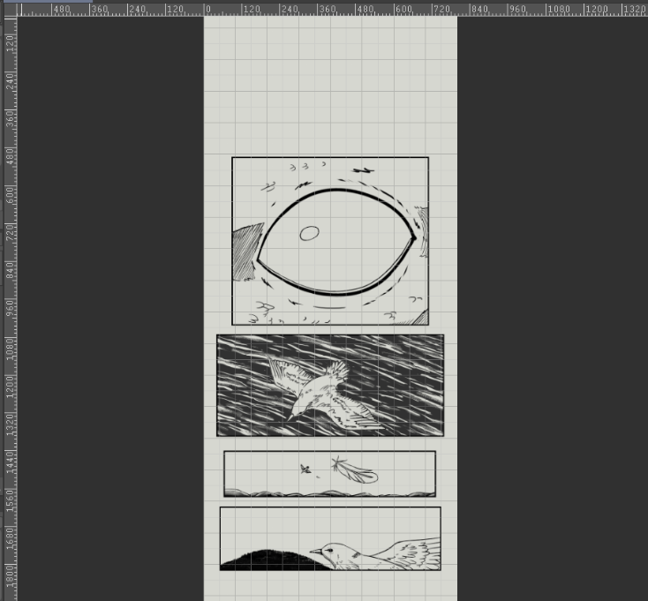 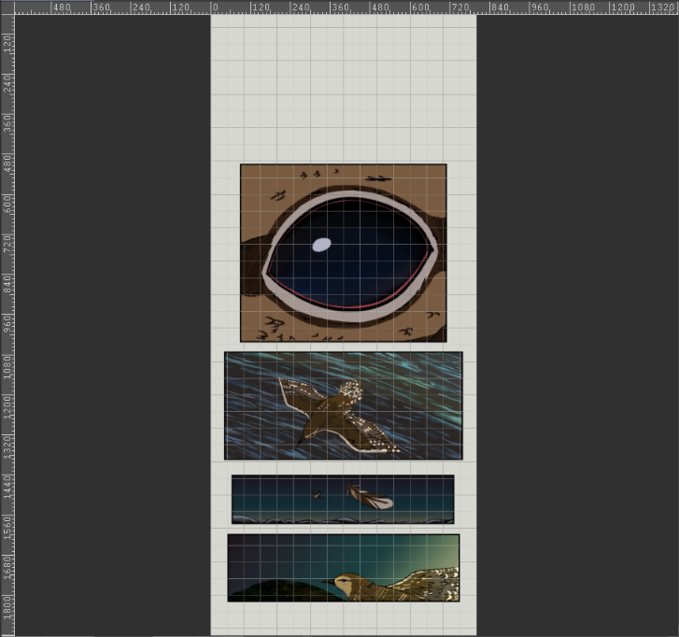

**Figure 3.** Inking and Coloring of Comic Page

As shown in Figure 3, Clip Studio Paint was used to ink and color the pages based on the storyboard. First, the layout was adjusted followed by the line art, based color, shading, lighting, text, and final details of the comic illustrations.

Comic Animation

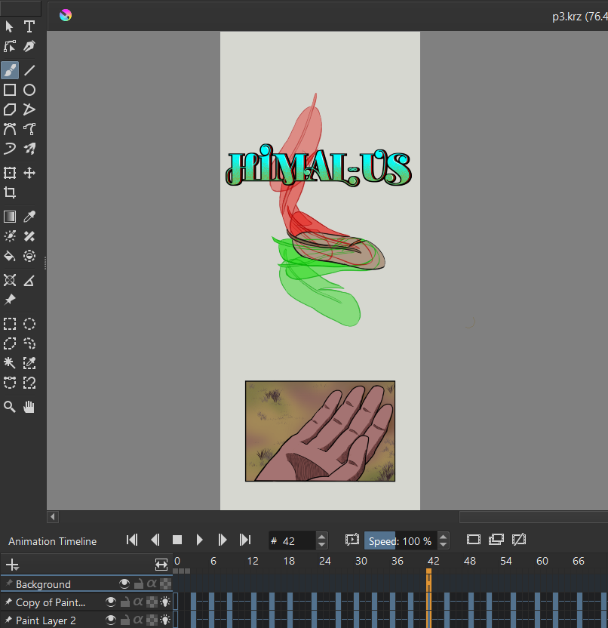

**Figure 4.** 2D Animation of the Comic Page

As shown in Figure 4, Krita was used for creating 2D frame-by-frame hand drawn 2D animation. The comic page was fully inked and colored before creating animations.

Website Architecture

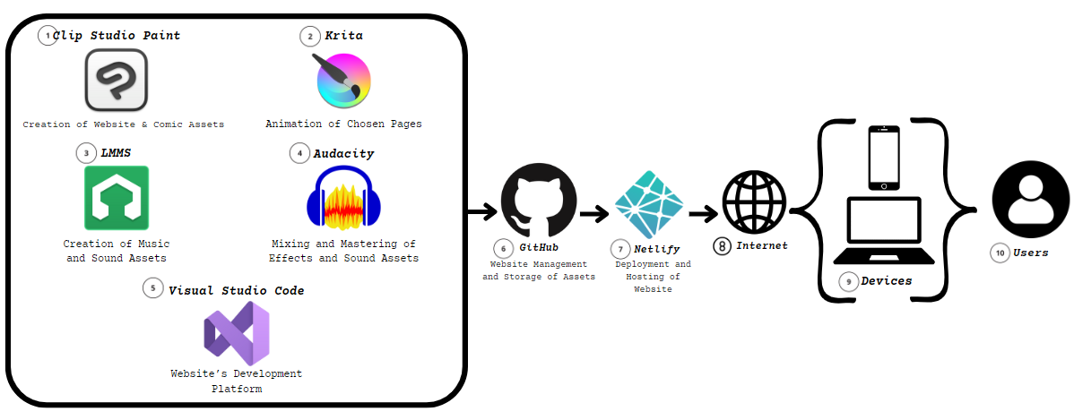

**Figure 5.**Comic Book Media Website Architecture

As shown in Figure 5, the construction of the website in this research with a system schematic was used. The design can be seen in Figure 5, with each component serving a specific purpose. The components used were: (1) Clip Studio Paint, (2) Krita, (3) LMMS, (4) Audacity, (5) Visual Studio, (6) GitHub, (7) Netlify, (8) Internet, (9) Devices, and (10) Users.

* Clip Studio Paint: A digital graphic art software application used to create the storyboard, draw 2D illustrations, and create animation for the comic book.
* Krita: A digital graphic art software used to create 2D animated panels for the comic book.
* LMMS: This digital audio workstation program was used to produce music by arranging samples, synthesizing sounds, and combining tracks.
* Audacity: This free and open-source digital audio editor and recording application software was used for mixing and mastering sound assets and effects.
* Visual Studio: The purpose of this component was to create the website platform and execute scripts that control the website and its interactions.
* GitHub: This open-cloud platform was used for the storage of audio and visual assets, making it accessible to online users.
* Netlify: This web platform was used to deploy and host the website.
* Internet: The internet was used to access the website that contains the multimedia-based comic book.
* Devices: These are computer hardware devices used to view the website and comic book.
* Users: This refers to the individuals who view the website containing the digitally published comic book.

Process Design

The primary step for creating the project in the design phase is character sketching. After writing the final draft of the comic script, the researchers made the 2D illustrations and animations of the multimedia-based comic book in Clip Studio Paint software. LMMS was then used to create the different sound effects and music, while Audacity was used for audio recording, editing, and mixing sound effects and music.

Production Process

The production process of developing a Multimedia Based Comic Book is divided into three stages: the pre-production stage, the production stage, and the post-production stage.

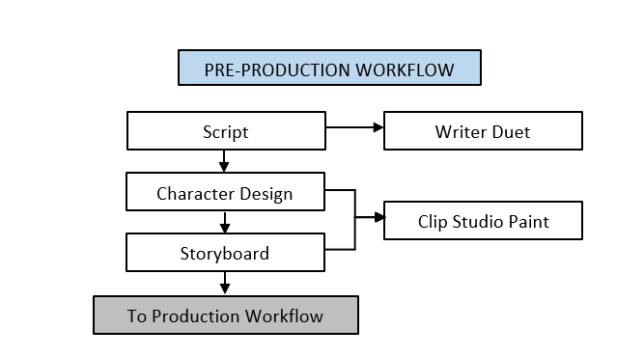

**Figure 6.**Pre-production Workflow

As shown in Figure 6, the conceptualization of ideas started in the pre-production stage. The script contained the storyline, scenes, actions, characters, and dialogue. The character designs of the characters were illustrated in a character turnaround model sheet as a reference for the artist used for the entire comic book illustrations. The storyboard was the visual representation of the script which consists of illustrated images formed in a sequence. After completing the pre-production stage, it proceeded to the production stage.

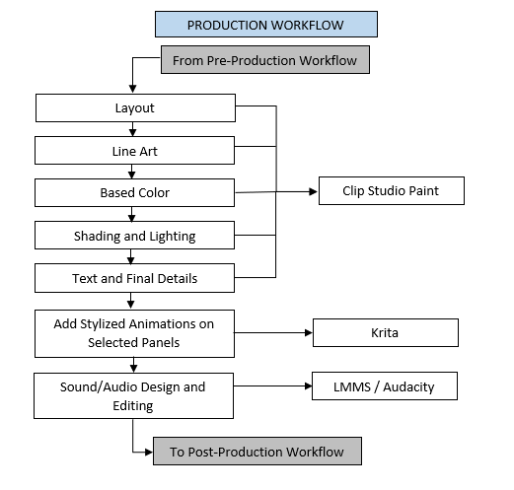

**Figure 7.** Production Workflow

As shown in Figure 7, this is where the comic’s production process occurred. Following the sequences of shots illustrated in the storyboard, the creation of the canvas and layout of panels in vertical format begins in Clip Studio Paint. Upon finalization of the panels, the line art process occurred. After finishing the line art, base colors were added, followed by shading and lighting to add depth and contrast. Finally, the text was added with elements such as dialogue, sound effects, and minor narrative. Finalizing the details completed the comic book in a static format. Specific panels were selected for the animation process, and minor stylized animations were added depending on the scene using Krita. The sound and audio recording and editing process took place separately in LMMS and Audacity for the background music.

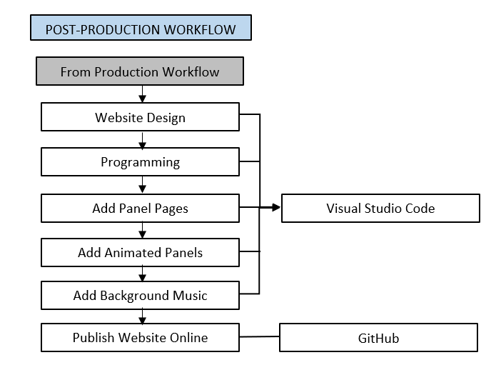

**Figure 8.** Post-production Workflow

As shown in Figure 8, the post-production stage is the final stage of the comic book creation process. Microsoft Visual Studio Code was used to create the scripts for the Graphic Interface of the website and it was where the programming took place. Static panels pages selected animated panels and background music were imported and arranged accordingly into the script of the website in a single webpage in a vertical format by scrolling up or down. Finally, all the files for the website were uploaded to the GitHub repository and published online. The website was tested for errors and fixes before the website link was shared online.

Sound Design

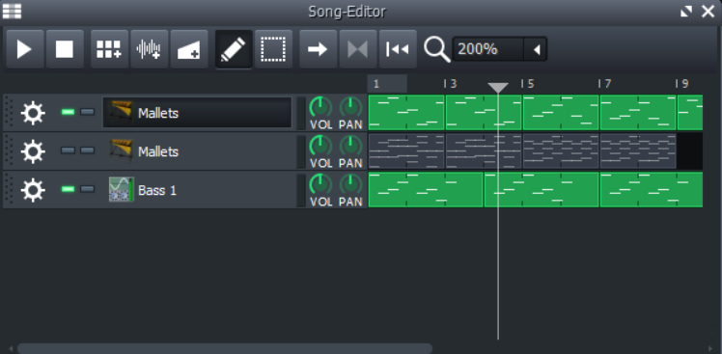

**Figure 9.** Music Creation

As shown in Figure 9, LMMS software application was used to create the music and foley for the comic book. An instrument plugin called Mallets was added and the instrument “Beats” was utilized for the rhythm and lead of the music. After the rhythm was finalized, a bassline was created to provide harmonic and rhythmic support to the music. After the music was finished, it was exported as a .wav file.

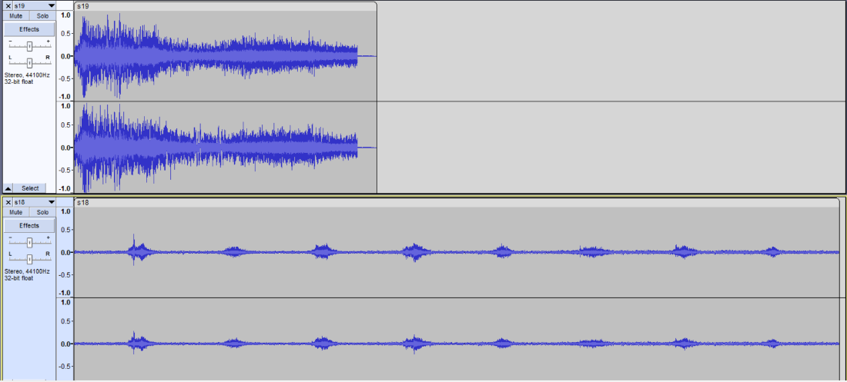

**Figure 10.** Audio Mixing

As shown in Figure 10, Audacity software application was used to import .wav files from LMMS and sound and music were further edited. Cuts and adjustments were made to enhance the overall music. Finally, the completed music was exported as .wav files to be added in the script for the website to be included in the comic book.

Website Development

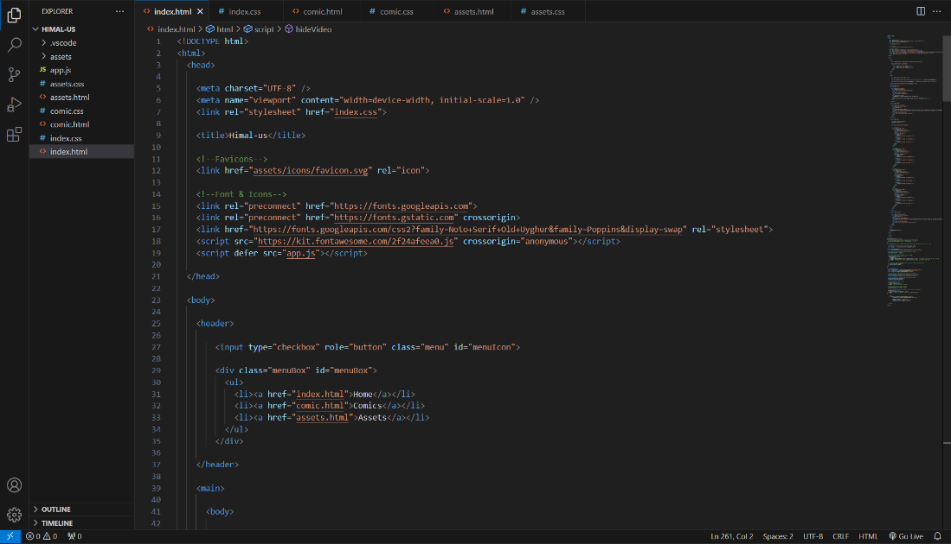

**Figure 11.** Website Programming

As shown in Figure 11, Visual Studio Code software application was used to create the overall website. HTML, CSS, and JavaScript are the main foundation of the website. HTML was used to create the foundation of the website. Each line of code represented a piece of the narrative puzzle, from defining the document type to creating the structure of the site. CSS was used to weave visual magic to the website. Each line of code in the stylesheet brought color, style, and coherence to the website from defining the body background to styling each section. JavaScript was introduced to add interactivity to the website. Every line of code in the script responds to the user’s actions and dynamically updates the content from handling navigation to creating engaging multimedia experiences.

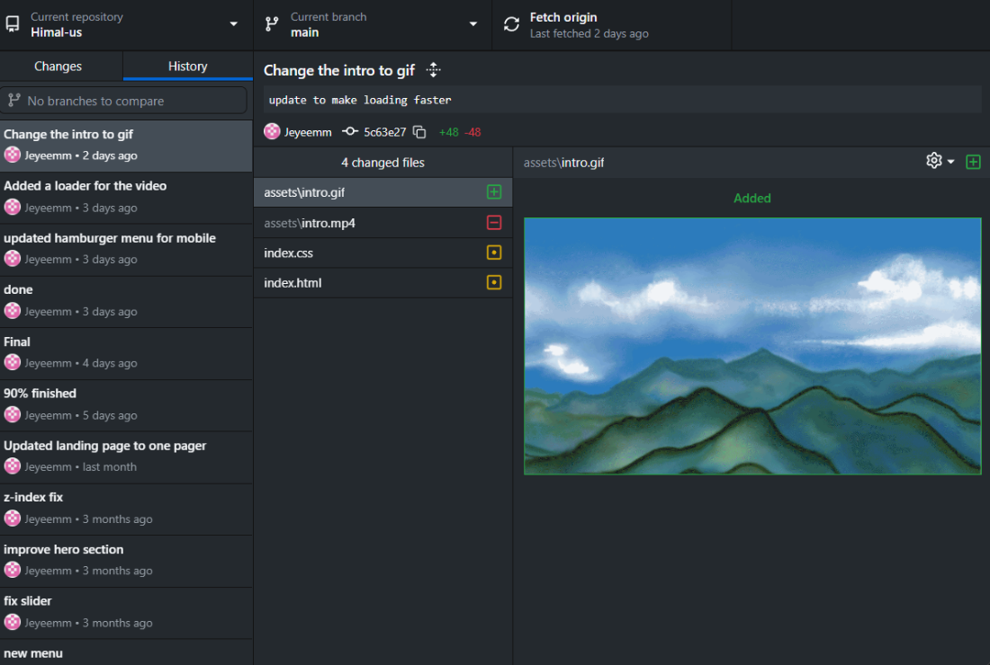

**Figure 12.** Tracking Changes to the Codebase

As shown in Figure 12, the GitHub software application was utilized to track changes to the codebase. GitHub repository was initialized in the project. This step marked the beginning of version control, allowing to track changes and collaborate seamlessly. Every HTML, CSS, and JavaScript file was carefully added to the staging area. Each addition symbolized a contribution to the evolving narrative of the website. The act of committing changes encapsulated a snapshot of the project at a specific point in time. With the local repository prepared, a corresponding repository was created on GitHub. Finally, a remote connection was established.

CHAPTER 4 RESULTS AND DISCUSSION

Implementation

In this chapter, the implementation of the methodology discussed in the previous chapter was emphasized and the results of each implementation were evaluated.

Himal-us Comic Book

The first objective was to create a digital comic book with unique characters, background music, and stylized animations. Before proceeding with the pre-production phase, the researchers visited Guimaras island province countless times to obtain their permission to gather as many information as possible regarding the forgotten Legend of Guima and Aras from reputable sources coming from the local historian. Furthermore, the researchers gathered many historical references from books, articles, the internet, and local shows to have an accurate representation of the historical events.

For the character design, the researchers ensured that the design reflects the personality that matches the character’s look and feel throughout the entire story while retaining their fashion style based on the era the story existed.

At the same time, using the WriterDuet application, the researchers developed the 9-page script for the storyline where the story was based to write ups of the local historian of Guimaras. The researchers took the time to flourish and improvise the story with additional details to events that were vague. Some scenes that were not mentioned by the local historian were added in order to fill some gaps that the story lacks so that it would make much more sense to the viewer. When the final script was finished, the researchers asked the local historian to validate and approve the script.

For the background design, the researchers asked permission to visit areas in Guimaras, to take photographs and record video footage of the areas recommended by the local historian and local government unit of Municipality of San Lorenzo and Sibunag. These were used as references when drawing background designs.

Clip Studio Paint was used to create character designs, storyboards, comic panels, background designs, and speech bubbles.

For the storyboard, each page resolution is 800 x 1920 pixels with 300 dpi, and all pages were exported separately as .png (PNG) file format converted to webp for vertical scrolling comic book format. This file was then included in the script of the website that the researchers have developed.

After the comic illustrations were completed, Krita was used to create 2D animations from selected comic panels to enhance the viewing experience of users.

For the website design, researchers created a website utilizing HTML, CSS, and JavaScript. Also, Microsoft Visual Studio Code was the advanced code editor that the researchers used in creating the website. The website consists of three pages: the home page, the comic page, and the asset gallery page. The home page is the landing page where users can access short animation of the story, foreword, meet the researchers, the mission, and the footer. The comics page features information about the characters and the content of the story. Lastly, the asset gallery page contains the entire assets of the comic Himal-us. The website ran through an online software development platform called GitHub to streamline collaboration ensuring a systematic approach to code management and the repository was deployed to Netlify for ensuring that the latest version of the website is accessible.

For music production, Audacity was used to create original background music, sound effects, and audio with the goal of helping immerse the user’s reading experience of the digital comic. The final audio output was exported as a .wav (WAV) file format then it was integrated into the script of the website. A button was also created to toggle the music on or off depending on the user’s preference. Moreover, the researchers utilized LMMS to create original compositions that were suitable to the feel of the comic. For additional sound effects, several royalty-free sound effects were downloaded then these were mixed to original recorded effects. Audacity was also used to clear out imperfections and distribute them throughout the comics.

Additional interactive features were added to the comic such as the tutorial, zoom, mute, and page slider.

The researchers tested the website to see if all the media files are working properly by using the storyboard. For the authenticity of the story, local historian in the province of Guimaras was asked to read the comic book using one of the researchers’ laptops and was asked regarding the storyline and his overall reading experience. The responses, feedback, and comments were recorded as a basis on the revision of the story and of the design accordingly.

For the comic illustration, the researchers used Clip Studio Paint to draw the overall layout and create panels, line art, coloring, shading, lighting, lettering of text, and animation. Krita was also used for animating chosen pages. Panels to be animated were carefully selected while other panels and scenes remained static. The purpose of adding the animation is to make the comic more engaging and interesting and to create an immersive reading experience for the user.

The files of the completed music and comic illustrations were encoded in the script of the website under the comic page. The comic page also includes the navigation bar at the bottom of the viewing screen so that users can easily navigate the comic page while reading.

After the website was fully developed, the researchers uploaded the codebase to GitHub and deployed it to Netlify for easy access. Users were required to have a computer device, phone and stable Internet connection to view the 64-page comic content online.

In order to ensure the smooth development and deployment of the comic book website, it is essential to consider the hardware and software specifications necessary for optimal performance as well as the web browser specifications to guarantee a seamless browsing experience for users. By carefully examining these specifications, this ensures that the website created is both functional and user-friendly, ultimately enhancing the overall user experience.

Hardware Specifications

Minimum Requirements:

* Storage: Sufficient storage provided by GitHub for hosting simple static websites.
* Networking: Managed by GitHub and Netlify’s infrastructure, capable of handling typical traffic for simple sites.

Recommended Requirements:

* Storage: Ample storage provided by GitHub and Netlify.
* Networking: Robust networking capabilities through Netlify, including CDN support for fast global content delivery.

Software Specifications

Minimum Requirements:

* Frontend: HTML5, CSS3, JavaScript.

Recommended Requirements:

* Frontend: HTML5, CSS3, JavaScript. Optionally, use a front-end framework like React or Vue.js for enhanced functionality.

Development and Deployment Specifications

Minimum Development Environment:

* IDE: Visual Studio Code or any suitable text editor (e.g., Sublime Text).
* Version Control: Git with GitHub for source control and collaboration.
* Local Testing: Live Server extension in VS Code for real-time browser updates during development.

Recommended Development Environment:

* IDE: Visual Studio Code or any full-featured IDE like WebStorm.
* Version Control: Git with advanced usage of GitHub features such as branching and pull requests.
* Local Testing: Use a local server setup (e.g., live server npm package) to test your website locally.

Minimum Deployment Environment:

* Continuous Integration Tools: GitHub Actions for simple CI/CD pipelines.
* Hosting: Netlify for deployment and hosting.
* CDN: Integrated CDN provided by Netlify.
* Backup and Recovery: Version control with GitHub acts as a backup for your website’s source code.

Recommended Deployment Environment:

* Continuous Integration Tools: GitHub Actions or Netlify’s built-in CI/CD features for automated builds and deployments.
* Hosting: Netlify for efficient and scalable deployment.
* CDN: Enhanced CDN configurations via Netlify for optimal global content delivery.
* SSL Certificate: Free SSL certificate provided by Netlify for secure connections.
* Backup and Recovery: Utilize GitHub for version control and leverage Netlify’s deploy previews for maintaining backup versions of your site.

Web Browser Requirements

Minimum Requirements:

* Browsers: Latest versions of major browsers such as Chrome, Firefox, Safari, and Edge.
* Compatibility: Ensure basic compatibility with HTML5, CSS3, and JavaScript standards.

Recommended Requirements:

* Browsers: Latest stable releases of major browsers (Chrome, Firefox, Safari, Edge).
* Compatibility: Regular testing across multiple browsers and devices to ensure consistent performance and appearance.
* Performance: Optimize website for fast loading times and responsiveness across different browser environments.

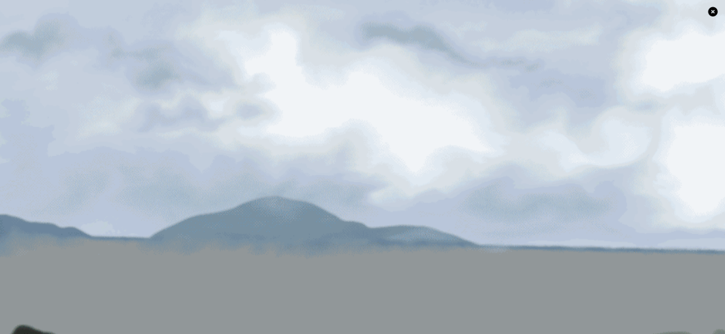

**Figure 13.** Animation Introduction

As shown in Figure 13, a short animation of Guimaras would be played once the user opens the website or the homepage.

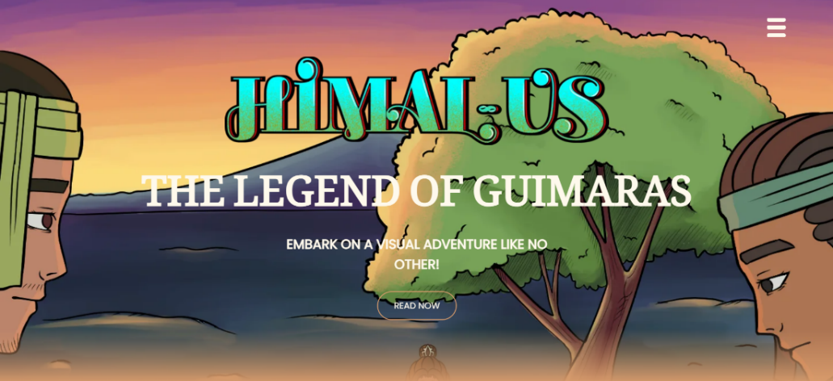

**Figure 14.** Hero Section

As shown in Figure 14, there is the hero section of the page where the comic book title can be seen and a call to action is stated.

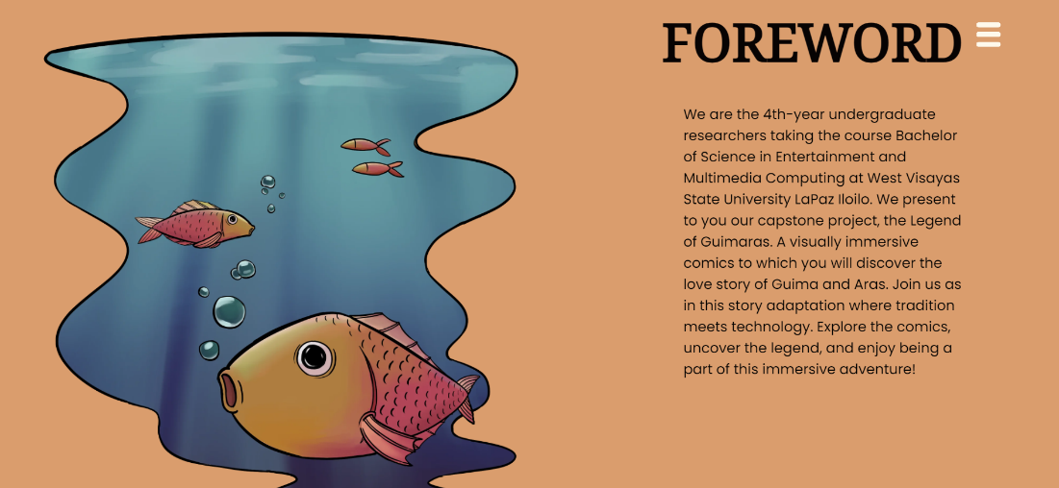

**Figure 15.** Foreword

Shown in Figure 15 is the foreword section of the page where the brief introduction of the researchers and of their comics can be seen.

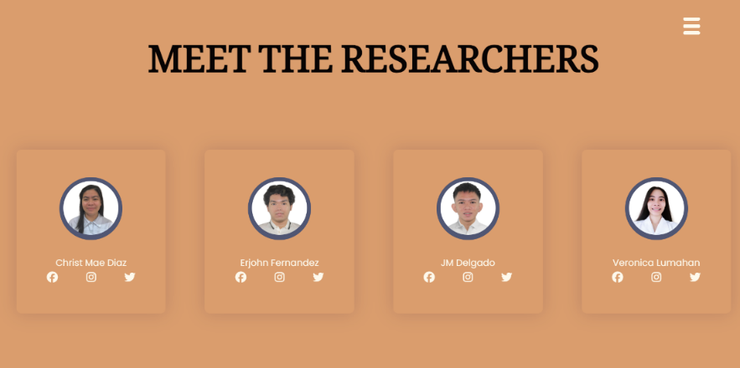

**Figure 16.** Meet The Researchers

As shown in Figure 16, the names of the researchers can be seen in the Meet the Researchers section.

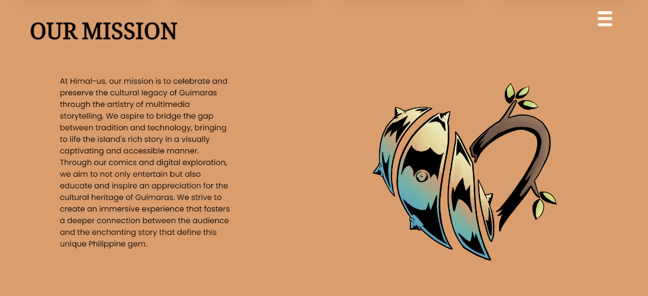

**Figure 17.** Mission

As shown in Figure 17, Our Mission Section, the mission statement of the researchers is presented.



**Figure 18.** Footer

As shown in Figure 18, the Footer section includes the group number and the copyright year.

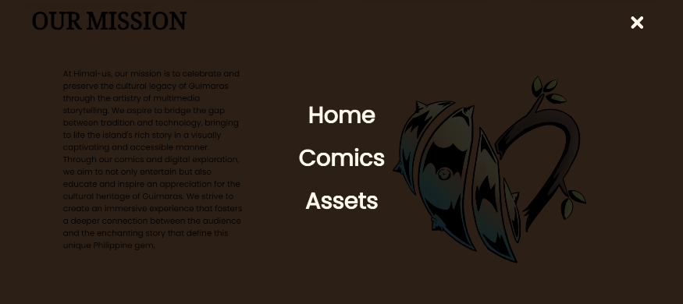

**Figure 19.** Menu

As shown in Figure 19, the menu can be accessed through the upper right corner of the screen by clicking on the drawer/three-line menu bar.

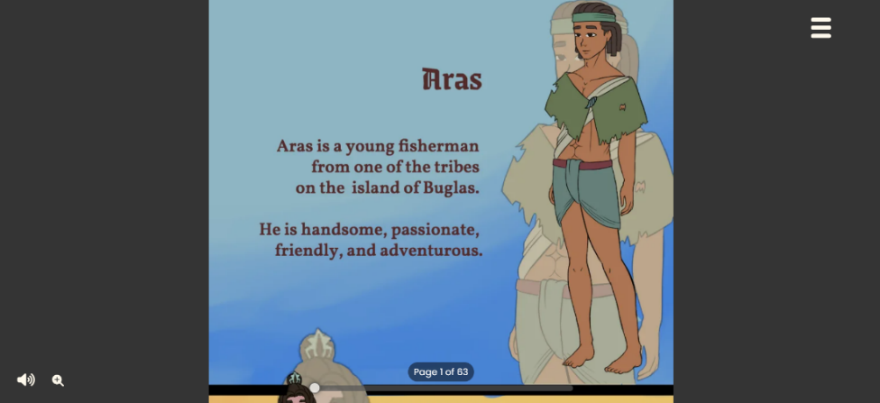

**Figure 20.** Comic

As shown in Figure 20, the comic webpage is where users can read the comic itself. It includes interactive elements such as the mute, zoom, and page slider can be seen at the bottom part of the screen.

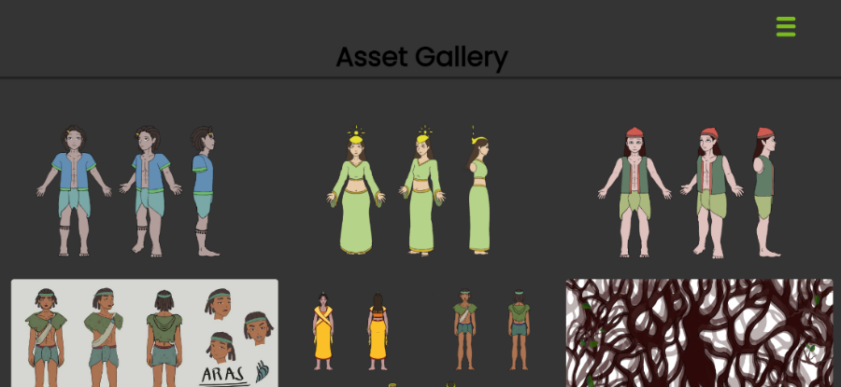

**Figure 21.** Asset Gallery

As shown in Figure 21, the asset webpage contains various assets, drafts, and resources that were used as references by the researchers.

The second objective was to create a story adaptation based on the tale of Himal-us focusing on the story of Guima and Aras. Before proceeding with the pre-production phase, the researchers consulted with a historian in Guimaras. The researchers then visited different libraries and local government units in Guimaras to outsource archives and articles related to Guimaras. The researchers went to the actual location to which the Legend of Guima and Aras originated. Then, they proceeded to the pre-production where they started by designing the characters for the comics. The storyboard was then created to plan for the cinematography and paneling of the comic. After that, the researchers proceeded to the production phase by drawing over it with proper details and line art. Once the inking process was finished, the researchers proceeded to the coloring stage comics where they started to color and render the pages. Lastly, they proceeded to do the animations where they draw by hand frame-by-frame to create the illusion of animation.

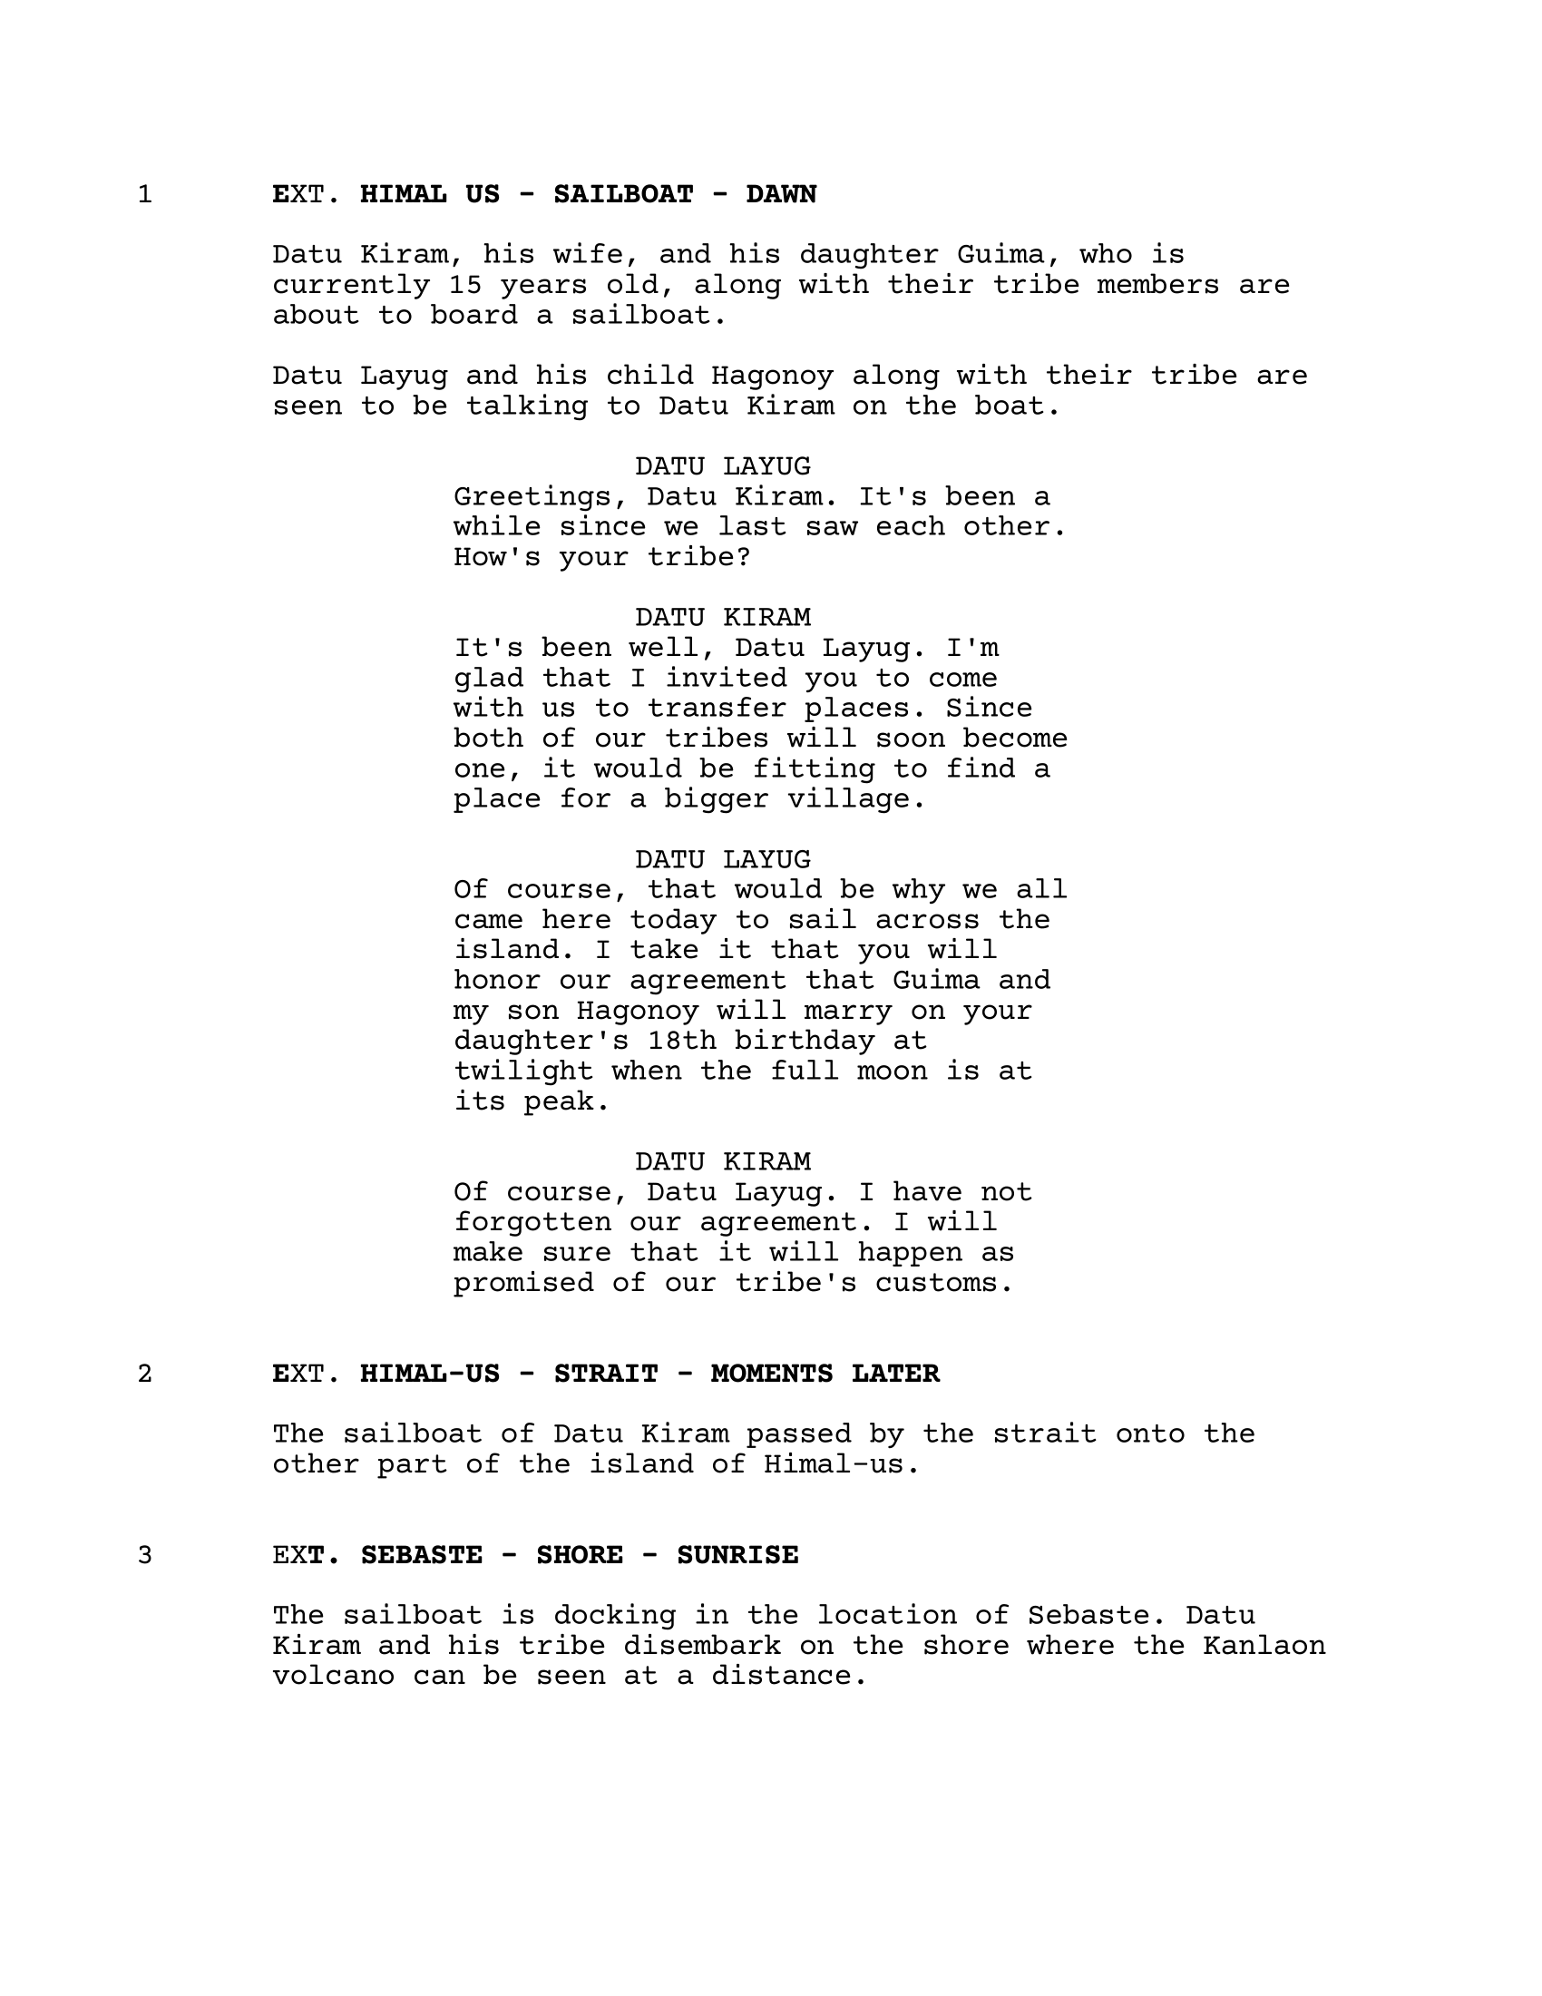 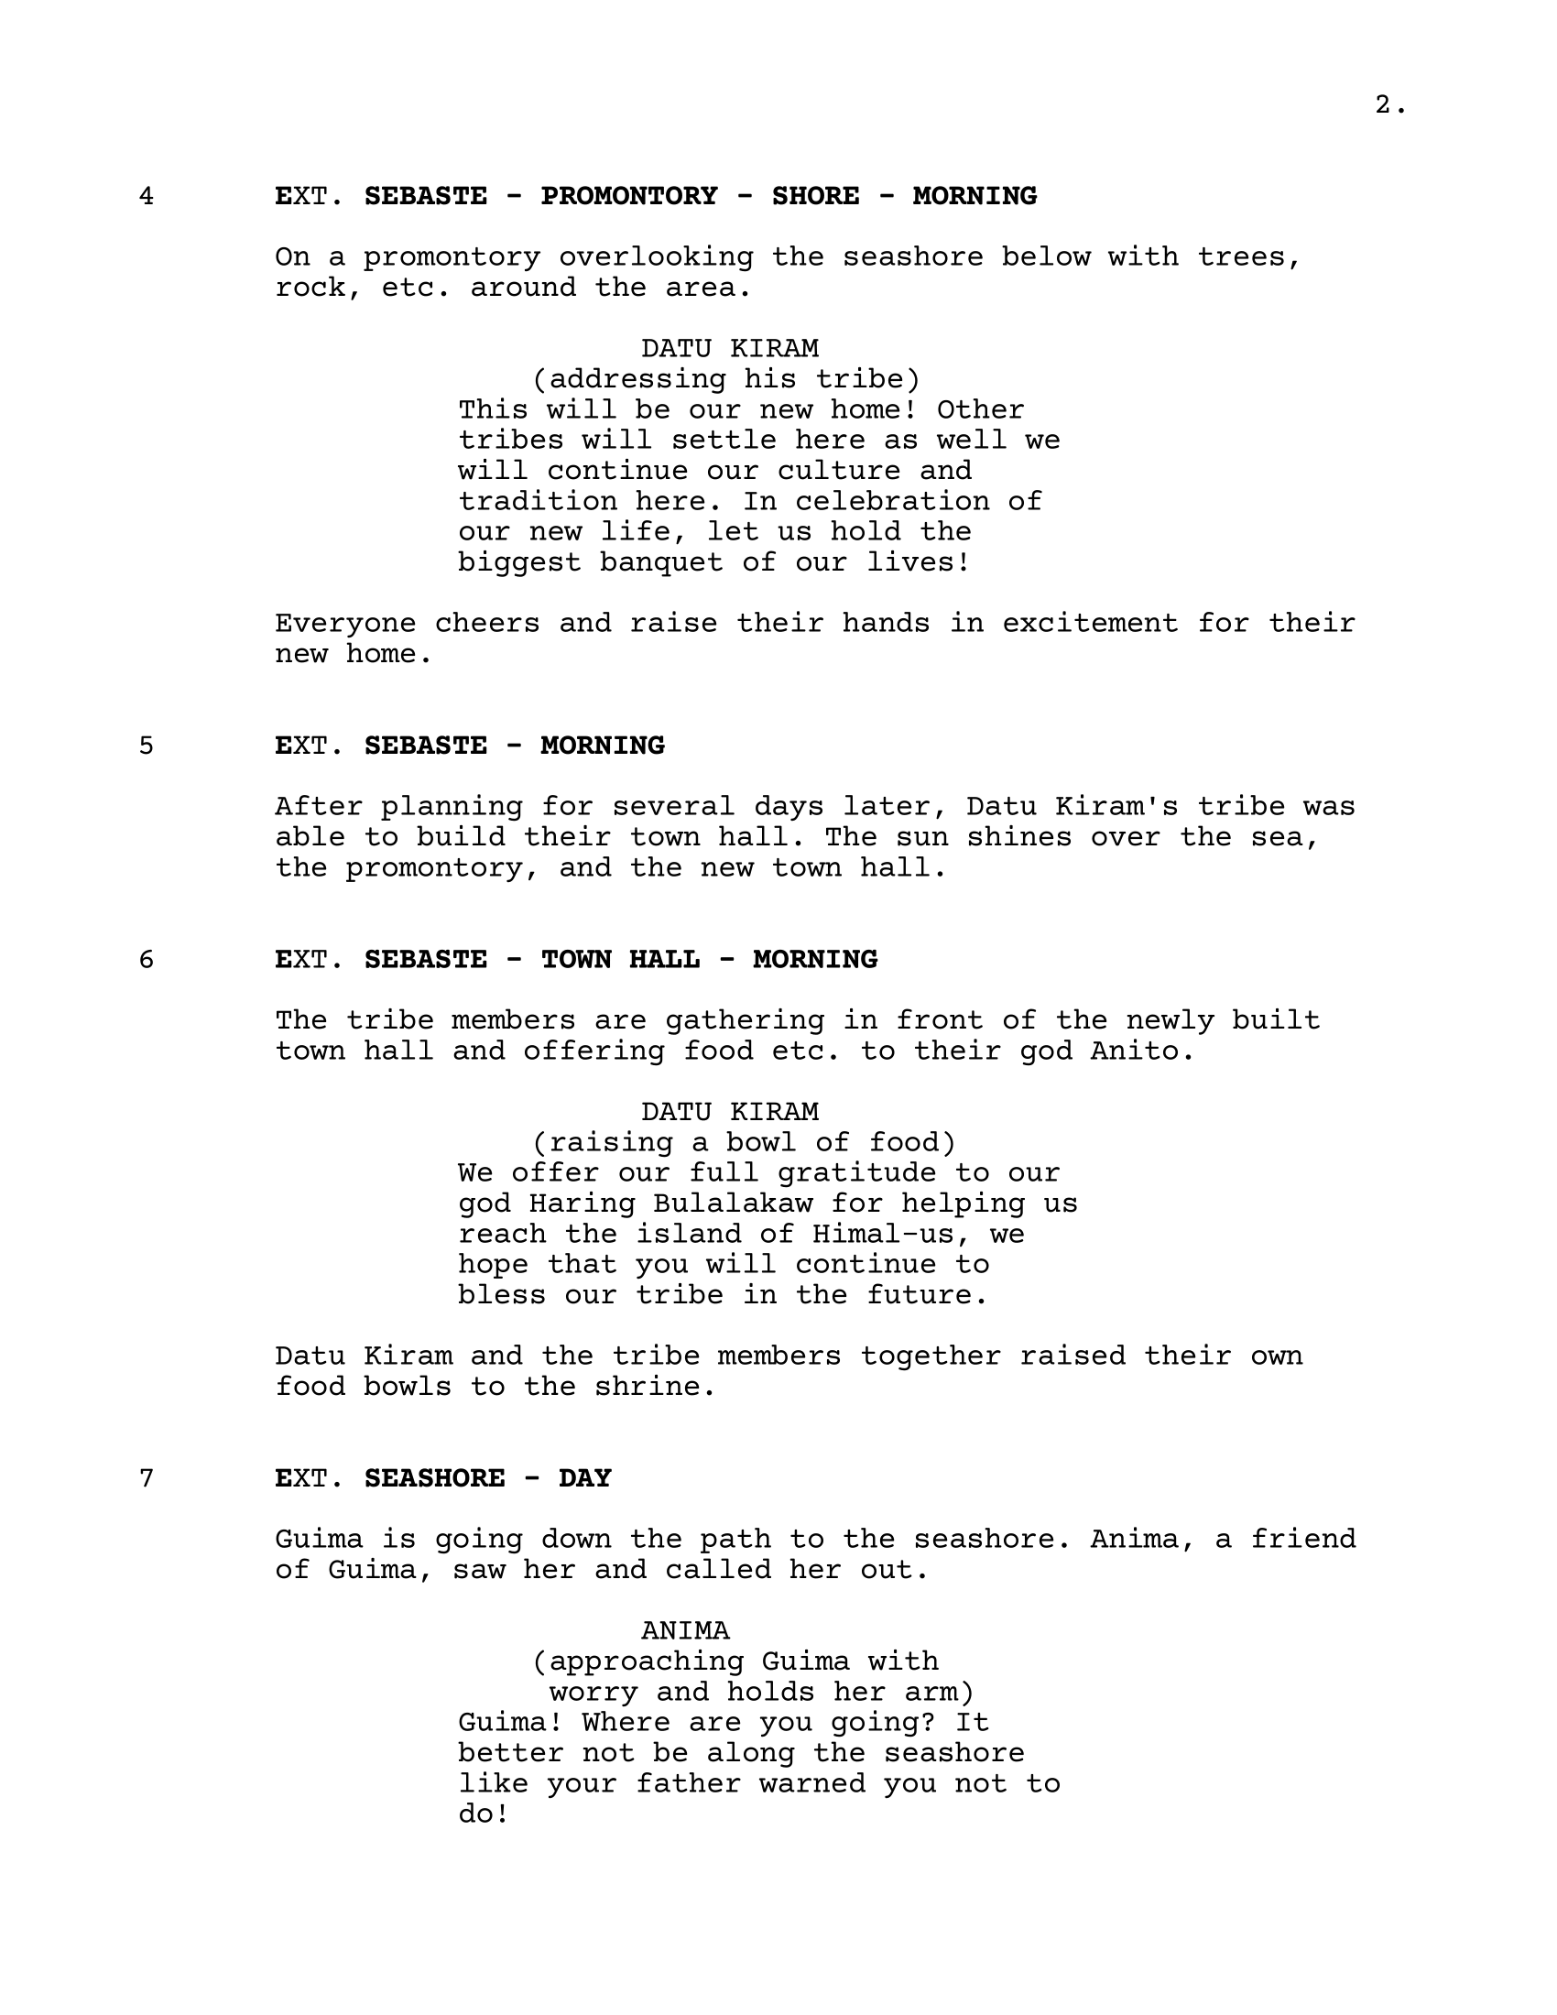

**Figure 22.** Script

As shown in Figure 22, the sample script is a document that comprises the scene, setting, action, characters, and dialogue of the story for the comic.

For the implementation of this objective, the researchers went to the recognized local historian for the existing manuscript of The Legend of Guima and Aras and gathered information to the location to which the Legend occurred. The researchers went to the barangay officials, and municipal tourism officer of Sebaste, San Lorenzo for site visit. Likewise, they went to the barangay officials and local government unit of Sebario, Sibunag Guimaras, Office of the Governor in the Province of Guimaras to gather primary and secondary documentaries and resources of the Legend. Since there are limited resources on Guimaras island, the researchers went to the Center of West Visayan Studies, U.P. Visayas, Iloilo City, where most of the background for this study was generated.

After a thorough reading and research on the origin of Guima and Aras, the creation of the manuscript followed, which included the revision and interpretation of local historian script into an original adaptation of the Guima and Aras Legend, the putting together, and the production of a 9-page with 12 scene comic script.

The third objective is evaluating the final output using usability evaluation. Researchers adapted a usability test comic book questionnaire and then revised its questions based on the Webcomic content. This questionnaire was used to survey 69 random participants residing inside and outside Guimaras island. The results were then interpreted using the Statistical Package for the Social Science (SPSS) software program.

Results Interpretation and Analysis

To evaluate the comic book, sixty-nine (69) respondents participated through convenience sampling.

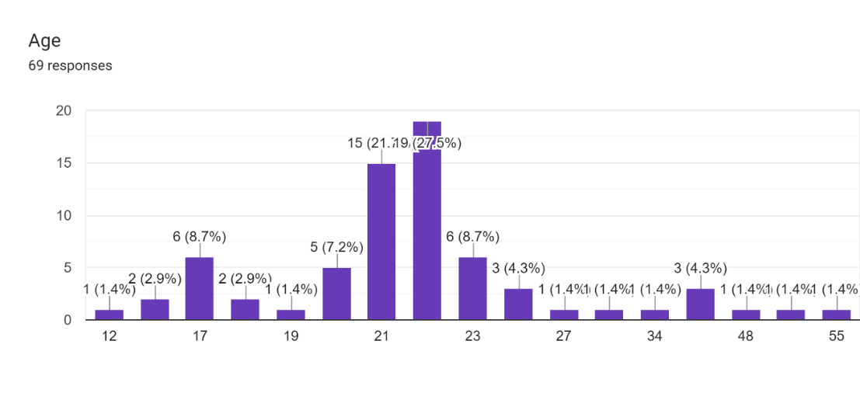

**Figure 23.** Demographic of the Respondents According to Age

As shown in Figure 23, there is a total of 69 respondents in the study. The respondents were categorized according to age: 12 years old *(1 or 1.4%),* 15 years old *(2 or 2.9)*, 17 years old *(6 or 8.7%),* 18 years old (*2 or 2.9%)*, 19 years old *(1 or 1.4%)*, 20 years old *(5 or 7.2%)*, 21 years old *(15 or 21.7%)*, 22 years old *(19 or 27.5%)*, 23 years old *(6 or 8.7%)*, 25 years old *(3 or 4.3%)*, 27, 29, and 34 years old *(1 or 1.4%)*, 37 years old *(3 or 4.3%)* and 48,54 and 55 years old *(1 or 1.4%)*.

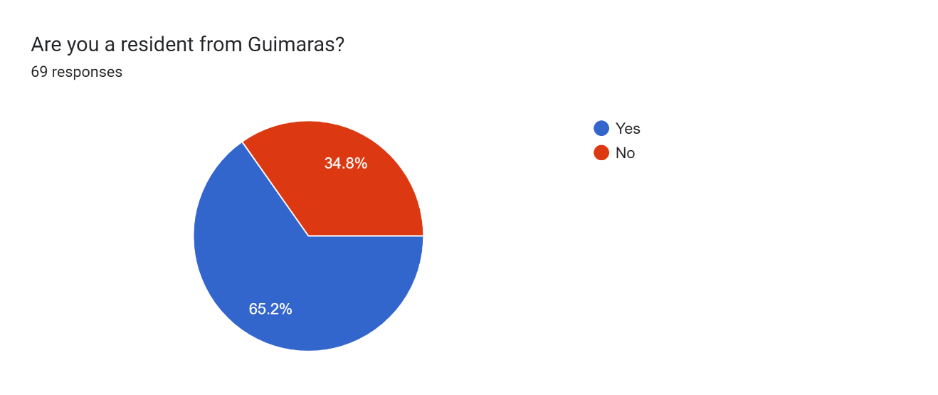

**Figure 24.** Demographic of the Respondents According to Residency

As shown in Figure 24, respondents are classified according on their residency, either residing inside and outside Guimaras island. Out of 69 respondents, 45 *(65.2%)* are residents of Guimaras and 24 *(34.8%)* are non- resident of Guimaras.

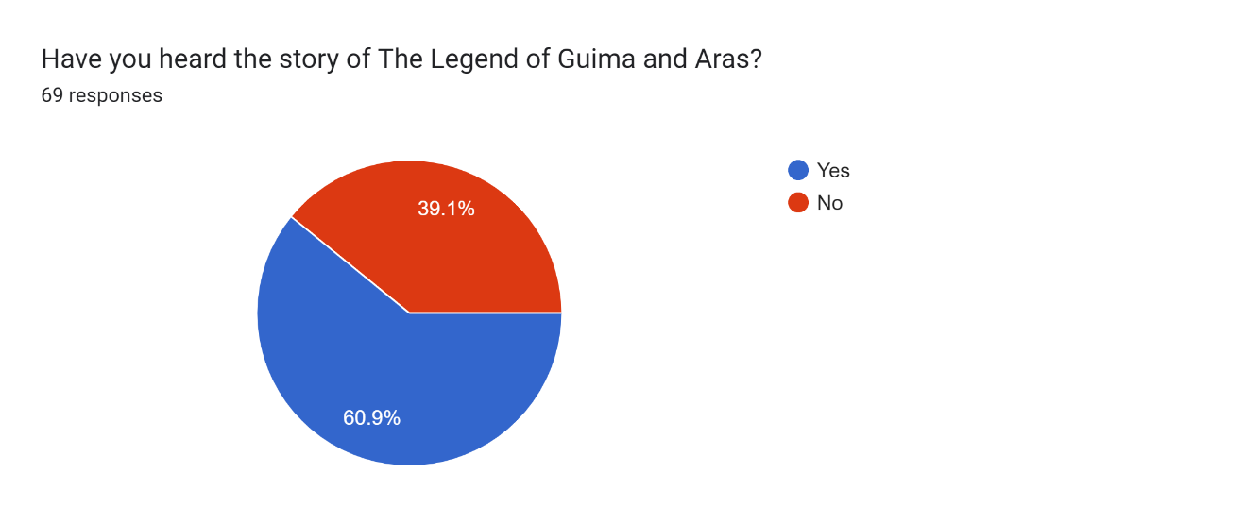

**Figure 25.** Demographic of Respondents According to Familiarity of The Legend of Guima and Aras

As shown in Figure 25, the demographic of respondents is measured on their familiarity and awareness of the existence of Guima and Aras Legend. Out of 69 respondents 42 *(60.9%)* answered yes and familiar, and 27 *(39.1%)* answered no or unfamiliar.

The researchers used the usability evaluation questionnaire taken from review article by Azman, Shiratuddin, and Zaibon (2019) to measure the entertainment aspect of the comic book. The researchers distributed the questionnaire via Google Form which contains the letter to the respondents, link to the website, and the questionnaire. The respondents were required to visit the website and read the comic book before answering the questionnaire.

To find out the results of the usability evaluation, the researchers used the Likert scale to measure the emotive aspect of the comic book which encompasses various elements that contribute to the overall enjoyment and engagement of readers.

The Likert scale contained five responses assigned with a numerical value: Poor (1), Fair (2), Average (3), Good (4), and Excellent (5).

To get the mean scores as well as the standard deviation, the data gathered from the usability evaluation were analyzed using the Statistical Package for the Social Science (SPSS) software program and interpreted using the 5-point Likert scale scoring range.

**Table 1**

5-point Likert Scale Scoring Range

|  |  |  |
| --- | --- | --- |
| **Value** | **Range** | **Interpretation** |
| 1 | 1.00 – 1.80 | Poor |
| 2 | 1.81 – 2.60 | Fair |
| 3 | 2.61 – 3.40 | Average |
| 4 | 3.41 – 4.20 | Good |
| 5 | 4.21 – 5.00 | Excellent |

The usability evaluation results were measured using the Likert scale range interpretation.

**Table 2**

Results of the Entertainment Aspect of the Comic

|  |  |  |  |
| --- | --- | --- | --- |
| **Entertainment Aspect** | **Description** | **Mean** | **Interpretation** |
| E1 - Visual Appeal | At what level are the comic's illustrations/photos/graphics are appealing and aid the reader in understanding the tone and mood of the story? | 4.23 | “Excellent” |
| E2 - Layout | To what extent do the pictorials and words complement one another? | 4.36 | “Excellent” |
| E2 - Layout | At what level are the contrast and effects used effectively to aid focus? | 4.32 | “Excellent” |
| E3 - Clear Instructions | To what extent does the story's pace, shot, direction natural & make sense to the reader? | 4.37 | “Excellent” |
| E3 - Clear Instructions | Are the characters' positions reasonably placed? | 4.40 | “Excellent” |
| E4 - Navigation | To what degree the comic panels, speech balloons and captions placement ease and flow of the story? | 4.26 | “Excellent” |
| E4 - Navigation | Is the white space between the text, frames, and illustrations help readers move through the comic, or are the pages too busy? | 4.29 | “Excellent” |
| E5 - Organization | To what degree does the comic have a well-described setting with a clear beginning, middle, and end? | 4.37 | “Excellent” |
| E6 - Plot | To what extent does the plot exhibit good development, imagination, and continuity? | 4.42 | “Excellent” |
| E6 - Plot | Does the resolution bring the conflict to a satisfying end? | 4.28 | “Excellent” |
| E7 - Characters | To what extent are the characters believable and well developed? | 4.38 | “Excellent” |
| E7 - Characters | Do the characters' pose, gesture & expression make sense in the story? | 4.49 | “Excellent” |
| E8 - Feedback | At what level do the plot and action necessarily give the user adequate direction and information for progressing to? | 4.39 | “Excellent” |

For the Entertainment Aspect of the comic book, every question garnered an “Excellent” interpretation with E7 – Characters having the highest mean score of 4.49 with the description “To what extent the characters are believable and well developed?”. Meanwhile, the E1 - Visual Appeal had the lowest mean score of 4.23 with the description “At what level the comic's illustrations/photos/graphics are appealing and aid the reader in understanding the tone and mood of the story?”.

CHAPTER 5 SUMMARY, CONCLUSIONS, AND RECOMMENDATIONS

Summary of the Proposed Study Design and Implementation

Comics are a powerful form of media especially in today’s digital age where anyone can access the internet. Information on the culture of Guimaras is close to non-existent as records have been damaged or lost in time. This is why the Himal-us website that is also compatible with mobile was produced by the researchers and had the goal of creating a digital comic that is educational while maintaining appeal.

Digital comics offer a wide range of applications in numerous fields of study, and it has made a substantial contribution to education. It has a lot of potential for making interactive and immersive books.

In this context, the development of Himal-us was completed by accomplishing a preliminary usability test of the capstone project. A group of 69 respondents were randomly chosen using convenience sampling and were asked to complete a satisfaction survey. Here are the results of the survey.

Summary of Findings

The research focused on the entertainment aspect of comic books, and the findings indicate consistently high levels of satisfaction.

Data were gathered using an online survey questionnaire with questions taken from a review article "Instrument for evaluating digital educational comic" (Azman et. al, 2019).

The findings of the study revealed the following:

* The results showed that the highest number of respondents are at the age of 22 years old which is 27.5% with 19 respondents. Meanwhile, the lowest number of respondents are at the age of 12, 19, 27, 29, 34, 48, 54, and 55 years old which is 1.4% with 1 respondent.
* Based on the gathered data, it revealed that most of the respondents are residents from Guimaras which is 65.2% than non-residents from Guimaras which is 34.8%. Considering whether they have heard about the story of The Legend of Guima and Aras, it revealed that 60.9% of the respondents have heard of the legend while 39.1% participants have not heard of it.
* The results revealed the mean scores of the Entertainment Aspect of the comic book with every question garnered an “Excellent” interpretation with E7 – Characters having the highest mean score of 4.49. This means that the characters are believable and are well developed. Meanwhile, E1 – Visual Appeal had the lowest mean score of 4.23, which means that the comic’s illustrations/photos/graphics are less appealing.

Conclusions

The research study conducted on the entertainment aspect of the comic has consistently gathered outstanding results. The careful examination of visual appeal, layout, clarity of instructions, navigation, organization, plot development, character portrayal, and user feedback has provided valuable insights into the strengths of the comic.

The findings show that the comic excels, earning an "Excellent" rating in each category evaluated. Specifically, the visual appeal, layout, and navigation elements contribute significantly to the seamless and engaging experience for readers. The well-organized plot, and satisfying resolutions, stands out as a key strength, complemented by believably crafted and consistently positioned characters.

Overall, the comic received positive feedback from the respondents. Furthermore, the research suggests opportunities for continued growth and innovation, including the exploration of new plot developments, improve user experience, and multimedia elements to elevate the storytelling experience.

In conclusion, the research findings showed the high quality and effectiveness of the comic in captivating its audience. The consistent excellence observed in entertainment aspects of the comic further suggests that the use of comic books is a powerful tool for visual literacy.

Recommendations

The study revealed that comics can improve visual literacy and can be used as a tool for entertainment. With this, the researchers would like to recommend the following:

* Creating comics should serve not only as a source of entertainment but also as a valuable tool for educational purposes.
* Optimize the multimedia elements for cross-platform compatibility to ensure a consistent and enjoyable experience across various devices. Consider differences in screen sizes, resolutions, and audio capabilities to provide a seamless experience for all users.
* Align the multimedia enhancements with the narrative arc of the comic. The background music and animations should not only be aesthetically pleasing but should also contribute meaningfully to the storytelling, enhancing the overall impact of the comic.
* Enhance the website's navigation to ensure a seamless and intuitive user experience. Consider implementing clear menu structures and navigation paths to guide users efficiently through the content.
* Optimize further the website for various devices by implementing responsive design principles. This guarantees a consistent and visually appealing experience for users accessing the site from different devices, including desktops, tablets, and smartphones.
* Optimize the website's performance by leveraging browser caching and minimizing unnecessary scripts. A fast-loading site contributes to user satisfaction and can positively impact search engine rankings.
* Evaluate the placement and visibility of call-to-action buttons or links. Ensure that important actions, such as contacting the team or accessing key information, are featured on the website.
* Prioritize accessibility by incorporating features such as alt text for images and ensuring that the website is navigable for users with disabilities. This demonstrates a commitment to inclusivity and widens the reach of the content.
* Optimize the placement of the texts and speech bubbles to ensure that the readers can have a clear and organized path when reading the comic to avoid confusion.

References

Azman, F. N., Shiratuddin, N., & Zaibon, S. B. (2019). Instrument for evaluating digital educational comic. *International Journal of Advanced Computer Research*, *9*(44), 316-324. 10.19101/IJACR.PID107

Beal, V. (2021). *Audacity*. Webopedia. https://www.webopedia.com/definitions/audacity/

Blin-Rolland, A. (2019). Becoming Musicomic: Music and Comics in Resonance. *Modern Languages Open*, *0*(1), 2. https://doi.org/10.3828/mlo.v0i0.235

Damayani, N., Hafiar, H., Rina, N., & Suminar, J.(2020). Character Education Based On Digital Comic Media. *International Association of Online Engineering*, *14*(3), 107-127. https://www.learntechlib.org/p/216555/

Department of Environment and Natural Resources. (2019). *Regional Profile*. Regional Profile - Iloilo City - DENR Offices. https://r6.denr.gov.ph/index.php/about-us/regional-profile#:~:text=Guimaras%20was%20formerly%20called%20Himal,us%20was%20changed%20to%20Guimaras

Dictionary.com. (n.d.). *Legend Definition & Meaning*. Dictionary.com. https://www.dictionary.com/browse/legend

Guffey, D. C. (2020). The Comic Book Conundrum: Defining Comic Books as a Literary Genre. *Honors Theses*, *724*. https://encompass.eku.edu/honors_theses/724

Gupta, V. (2021). An Approach to Develop Interactive Comics through Visual Computing. *Indian Institute of Technology Jodhpur Computer Science and Engineering*. https://cse.iitj.ac.in/images/pdf/project-reports/MT19CS020_Thesis_Final.pdf

Heller, M. (2022). *What is Visual Studio Code? Microsoft’s extensible code editor*. InfoWorld. https://www.infoworld.com/article/3666488/what-is-visual-studio-code-microsofts-extensible-code-editor.html

Industrial Scripts. (2019). *An Honest WriterDuet Review: Is It Worth It?* Industrial Scripts. https://industrialscripts.com/writerduet-review/

Juviler, J. (2022). *What Is GitHub? (And What Is It Used For?)*. HubSpot. https://blog.hubspot.com/website/what-is-github-used-for?hubs_content=blog.hubspot.com%2Fwebsite%2Fwhat-is-github-used-for&hubs_content-cta=What%20is%20GitHub%3F

Karlimah, K., Hamdu, G., Pratiwi, V., Herdiansah, H., & Kurniawan, D. (2021). The development of motion comic storyboard based on digital literacy and elementary school mathematics ability in the new normal era during covid-19 pandemic. *Journal of Physics: Conference Series*, *1987*(1), 012026. 10.1088/1742-6596/1987/1/012026

Kirchoff, J. (2017). Using Digital Comics to Develop Digital Literacy: Fostering Functionally, Critically, and Rhetorically Literate Students. *Texas Journal of Literacy Education*, *5*(2), 117-129. https://eric.ed.gov/?id=EJ1162692

LMMS. (2022). *FAQ*. LMMS User Manual. https://docs.lmms.io/user-manual/getting-started/faq

Maity, J. (2022). Comics in Digital Forms: An Overview and Growth of Digital Comics in the Present Era. *Contemporary Literary Review India*, *9*(1), 86-98. https://doi.org/10.201411/clri.v9i1.1039

Merriam-Webster. (n.d.). *Multimedia*. Merriam-Webster.com dictionary. https://www.merriam-webster.com/dictionary/legend

Minarno, E. B., Nurharini, F., & Utami, U. (2022). DEVELOPMENT OF LEARNING COMIC ANIMATION MEDIA BASED ON PORTABLE ISPRING APPLICATION OF LIGHT PROPERTIES TO IMPROVE SCIENCE LITERACY. *Proceeding Of International Conference On Islamic Education (ICIED)*, *7*(1), 233-243. http://conferences.uin-malang.ac.id/index.php/icied/article/view/2038

Pedri, N. (2022). *A Concise Dictionary of Comics*. University Press of Mississippi.

Russell, S. (2019). Comics in the Evolving Media Landscape. *Honor Scholar Theses*, *122*. https://scholarship.depauw.edu/studentresearch/122

Serra, L. (2021). *Clip Studio Paint by Example: Understand how to Use CSP in a Faster and More Productive Way for Concept Art, Illustrations, and Comics*. Packt Publishing.

Stenberg, L. (2020). Interacting with comics in digital spaces: Exploration into the intersection between interaction design and digital comics. *Malmö universitet/Kultur och samhälle*, 37. http://urn.kb.se/resolve?urn=urn:nbn:se:mau:diva-22283

*What is Krita?* (2019). Computer Hope. Retrieved December, 2023, from https://www.computerhope.com/jargon/k/krita.htm

Williams, M. (2022). *Netlify review*. TechRadar. https://www.techradar.com/reviews/netlify

Yunita, F. (2019). The use of Google Form application as media for students' assessment. *Proceedings of the 3rd INACELT (International Conference on English Language Teaching)*, *3*(1), 118-126. https://e-proceedings.iain-palangkaraya.ac.id/index.php/INACELT/article/view/88

Appendices

Appendix A

Letter to the Adviser

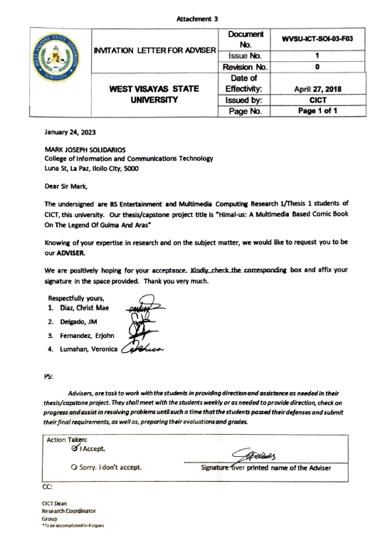

Appendix B

Letter to the Historian

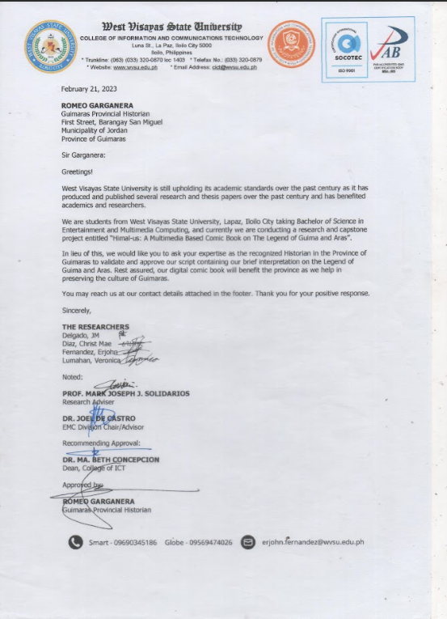

Appendix C

Letter to the LGU of San Lorenzo

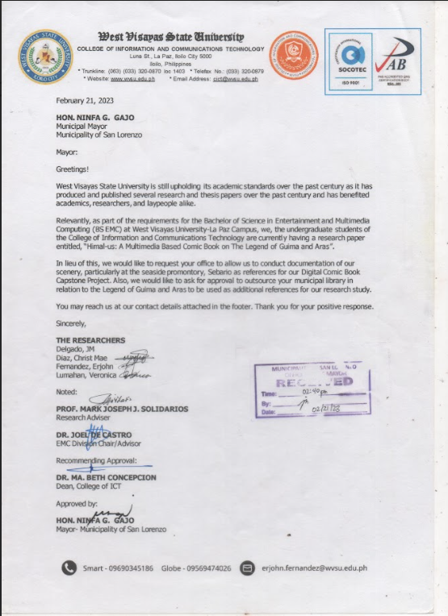

Appendix D

Letter to the LGU of Sibunag

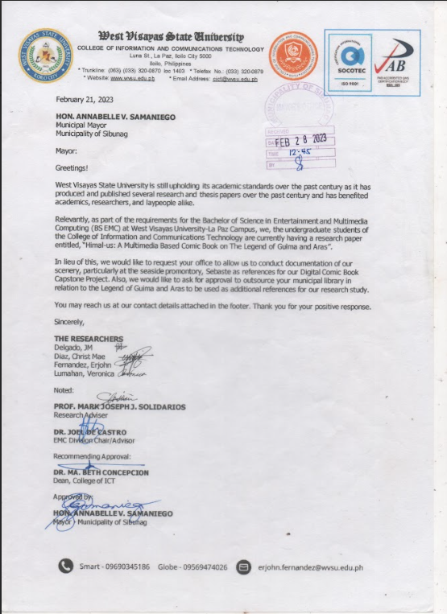

Appendix E

Letter to the Tourism Office of San Lorenzo

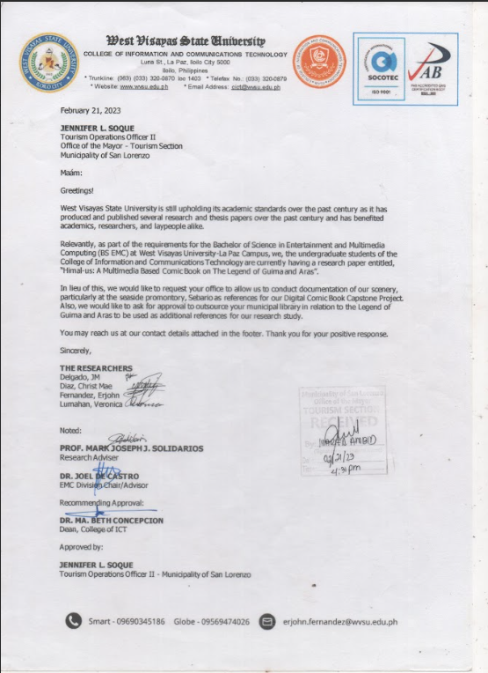

Appendix F

Letter to the LGU of Brgy. Sebario

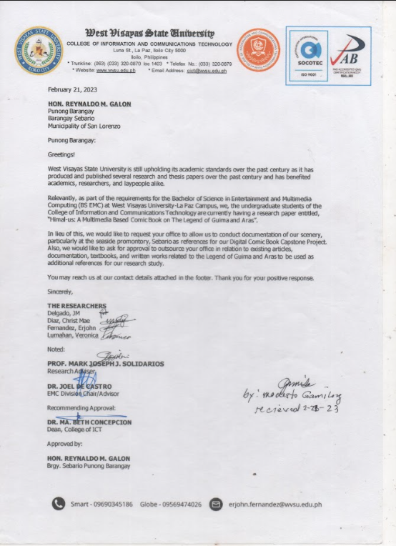

Appendix G

Letter to the Center of West Visayas Studies-UPV

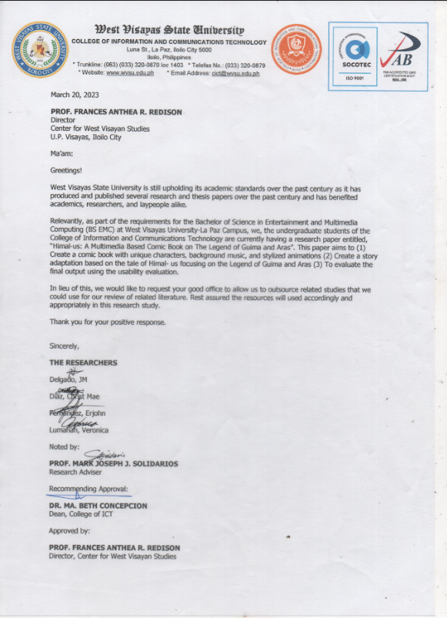

Appendix H

Letter to the Comic Validator

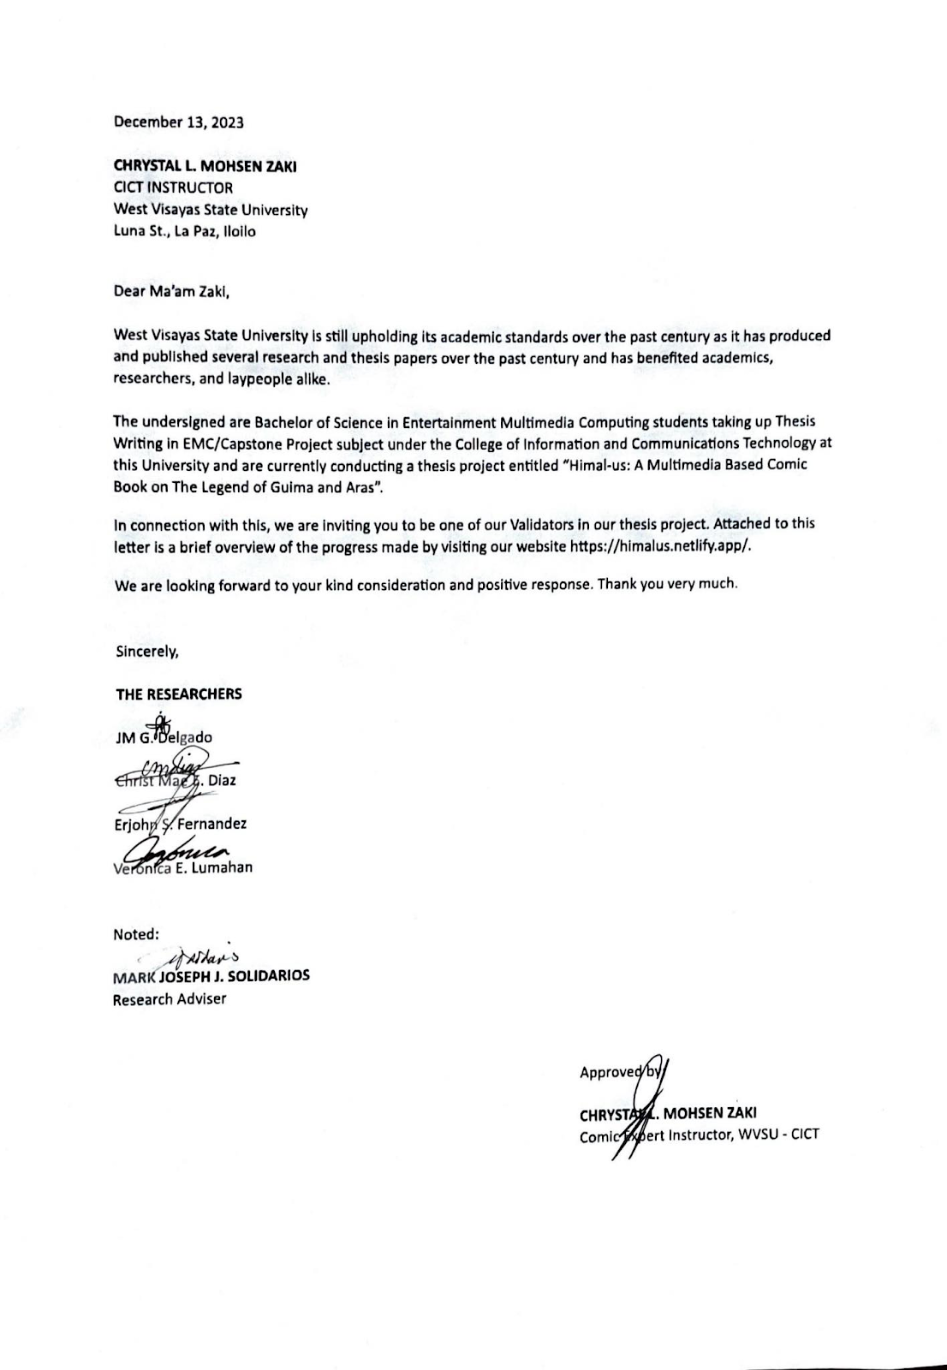

Appendix I

Letter to the Website Validator

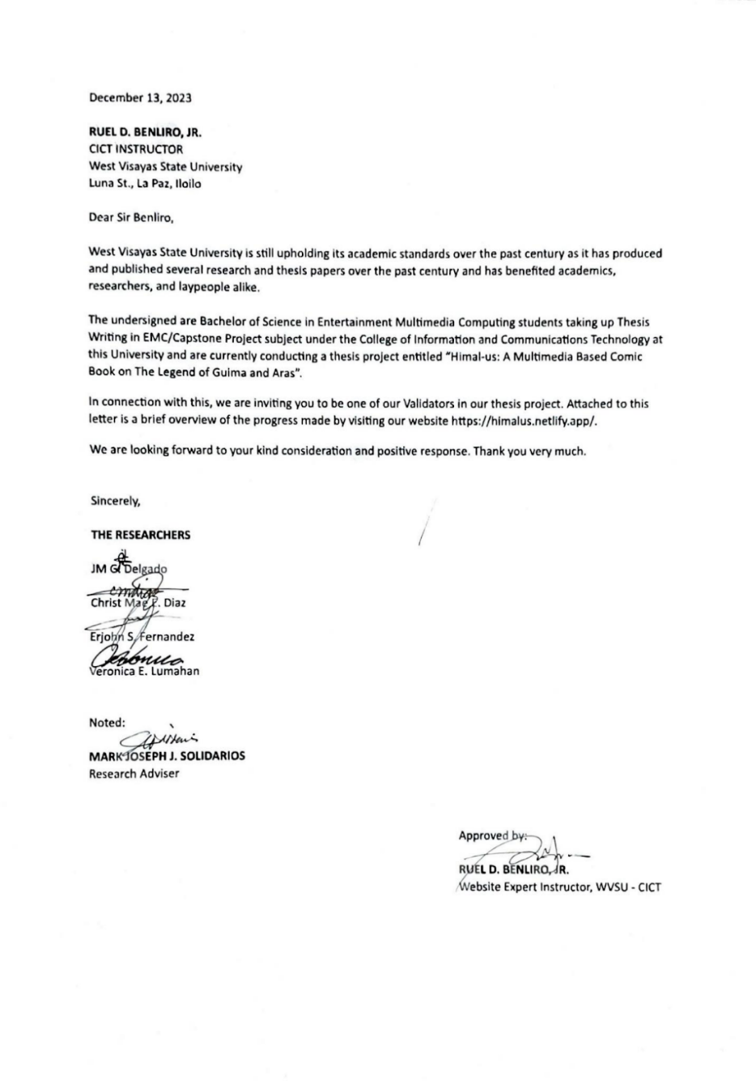

Appendix J

Letter to the Local Historian Validator

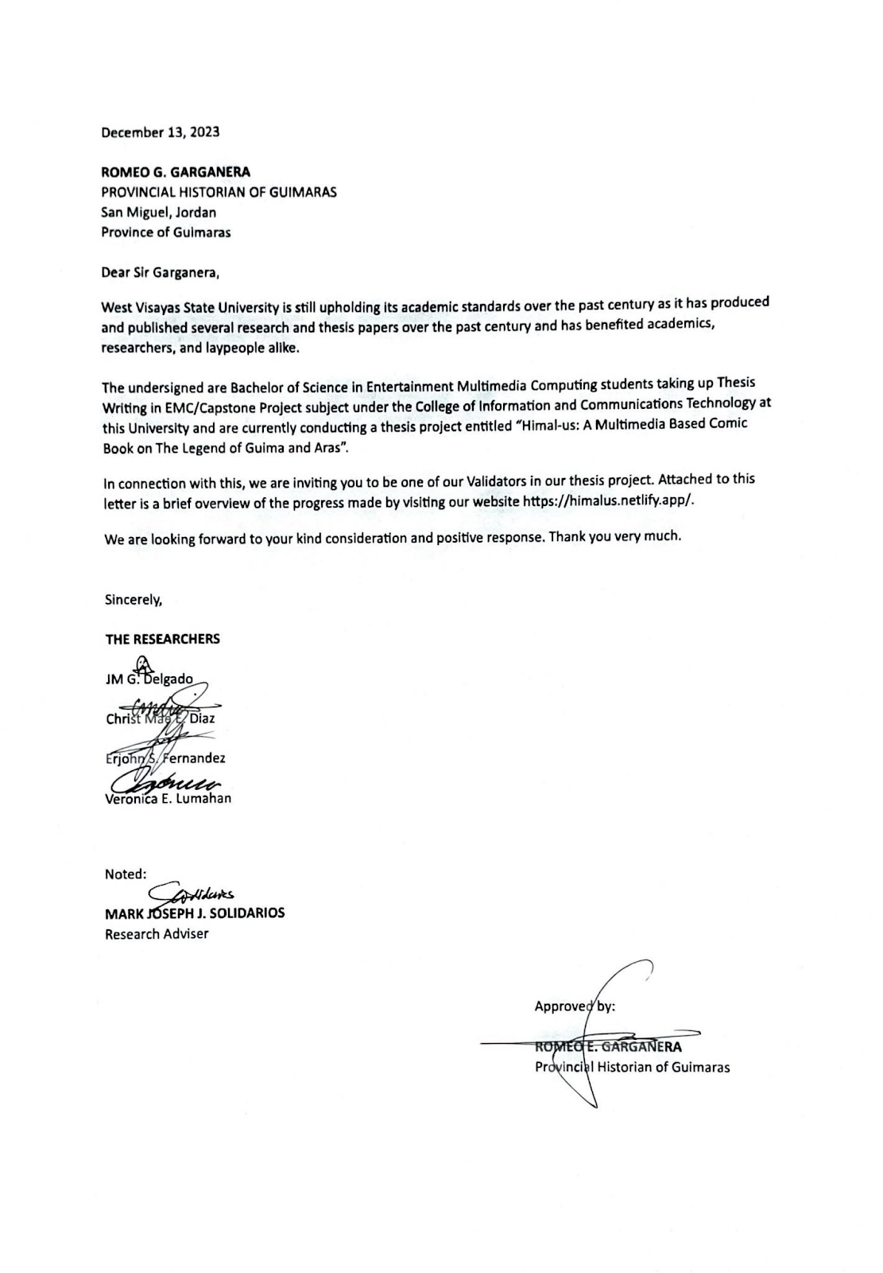

Appendix K

Certificate of Validation 1

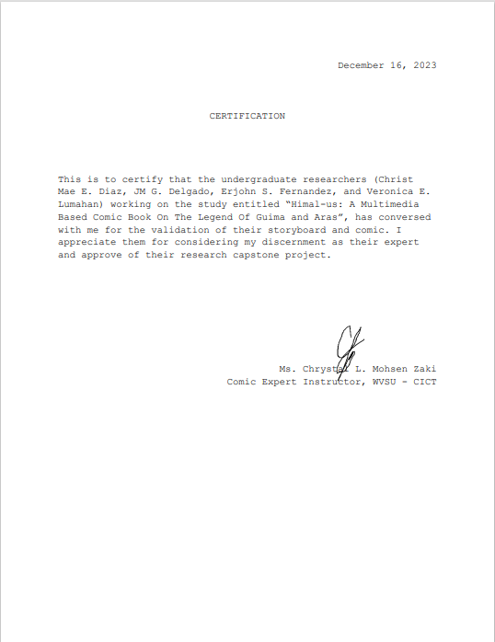

Appendix L

Certificate of Validation 2

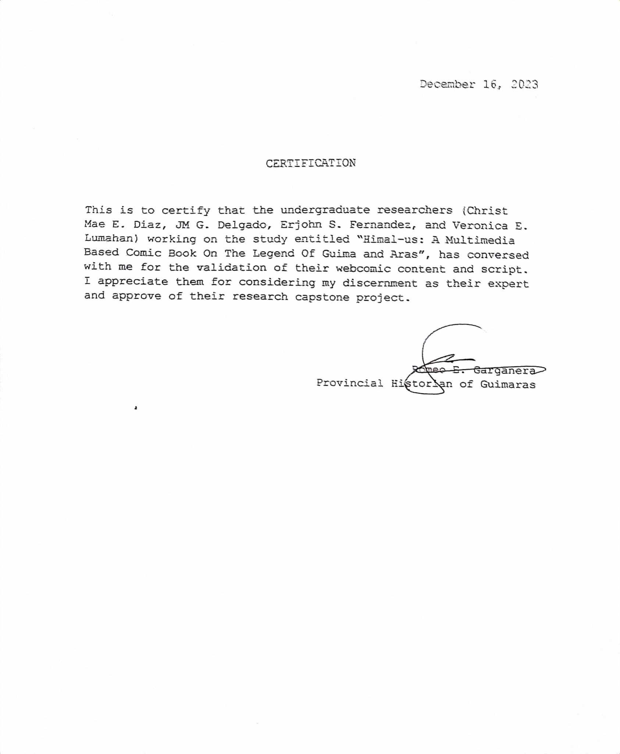

Appendix M

Certificate of Validation 3

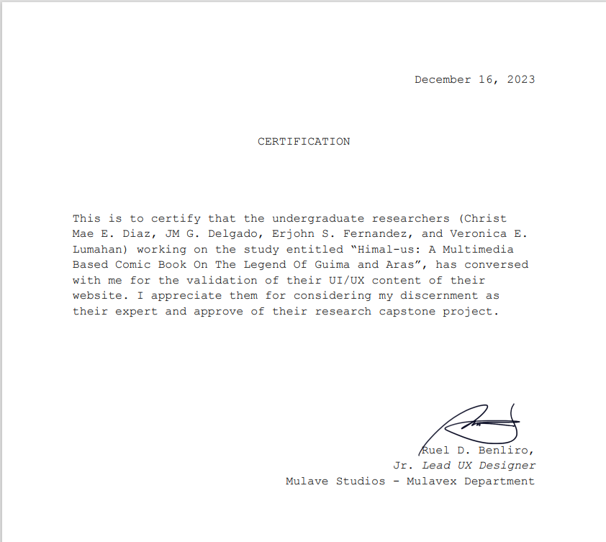

Appendix N

Adviser Recommendation to Technical Editor

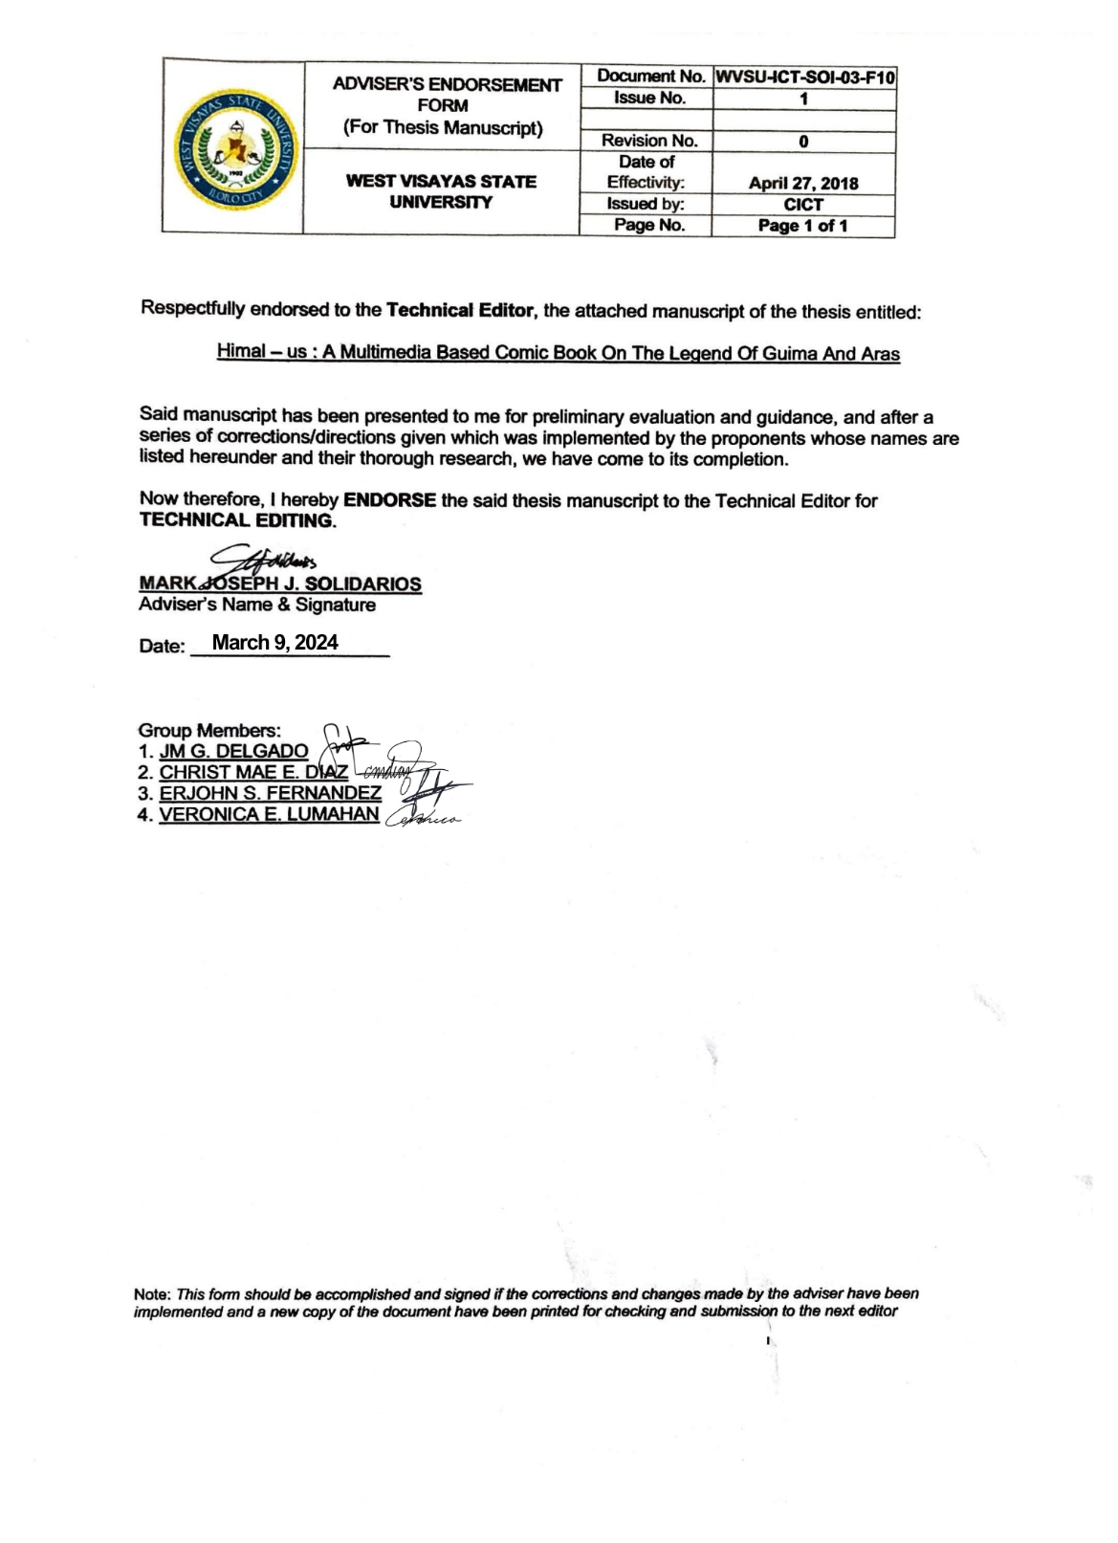

Appendix O

Letter of Technical Editor to Grammarian

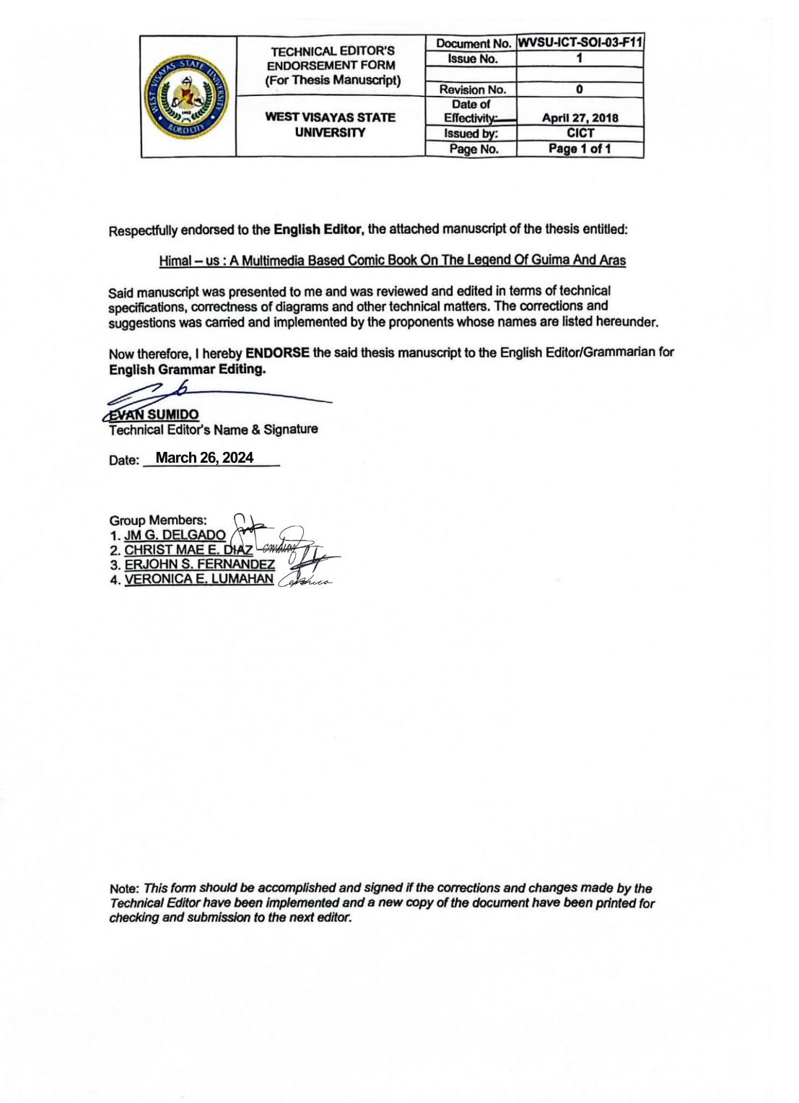

Appendix P

Letter of Grammarian to Format Editor

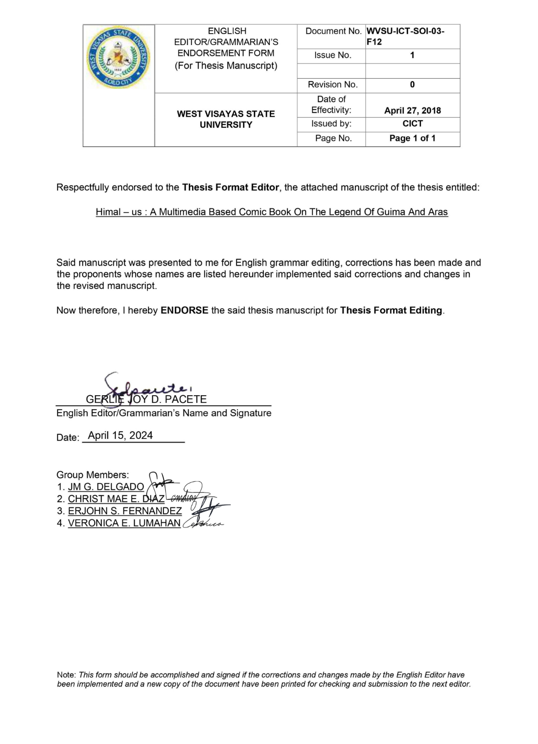

Appendix Q  
Letter of Format Editor to Thesis Coordinator  
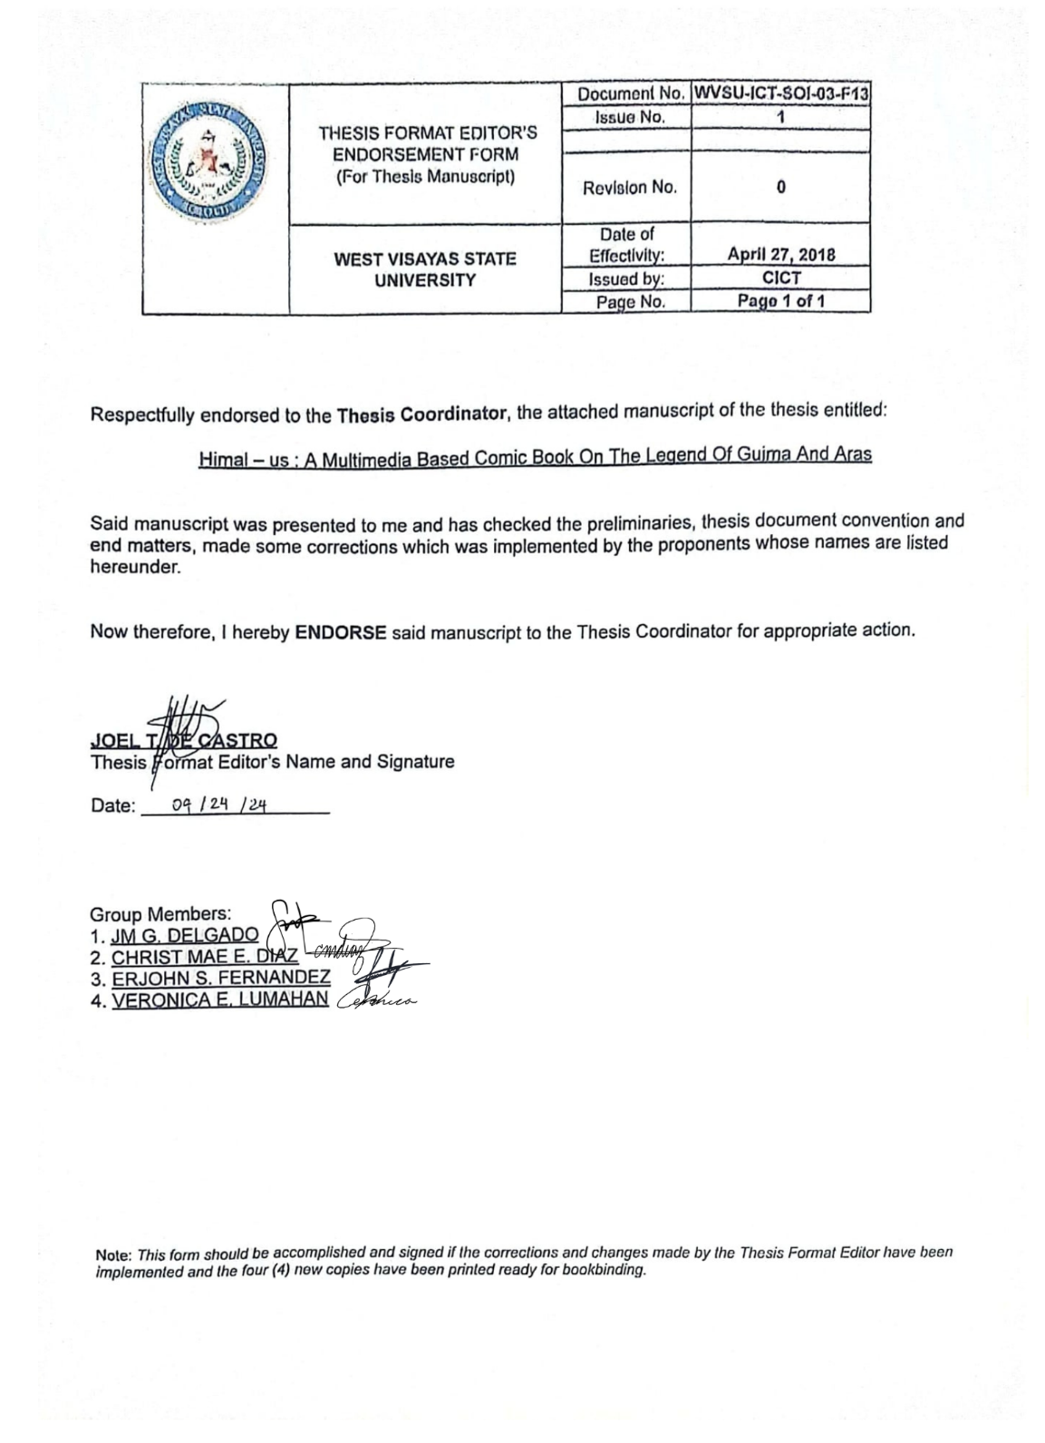

Appendix R

Certification of Bookbinding

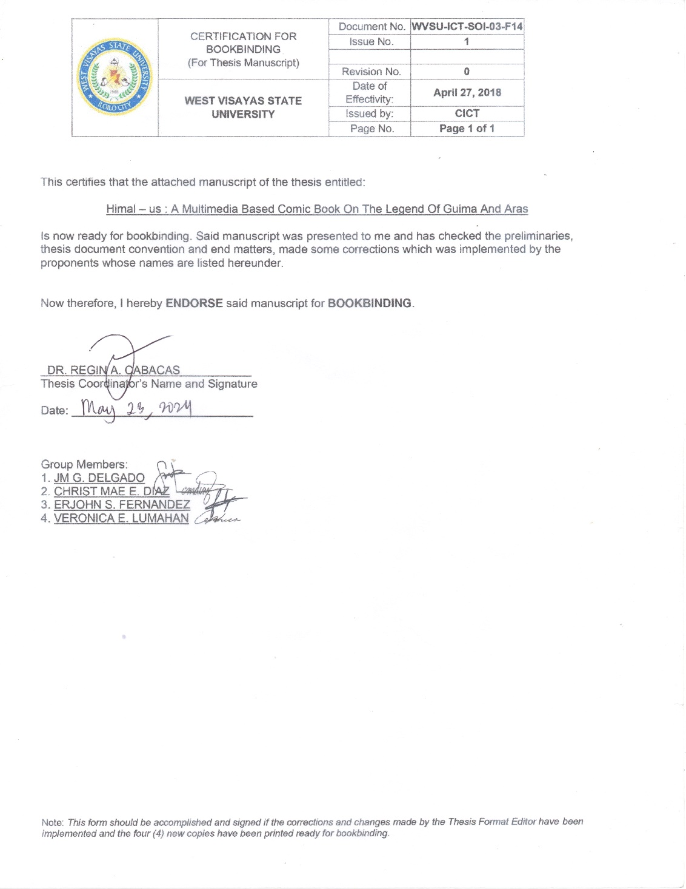

Appendix S

Sample Script

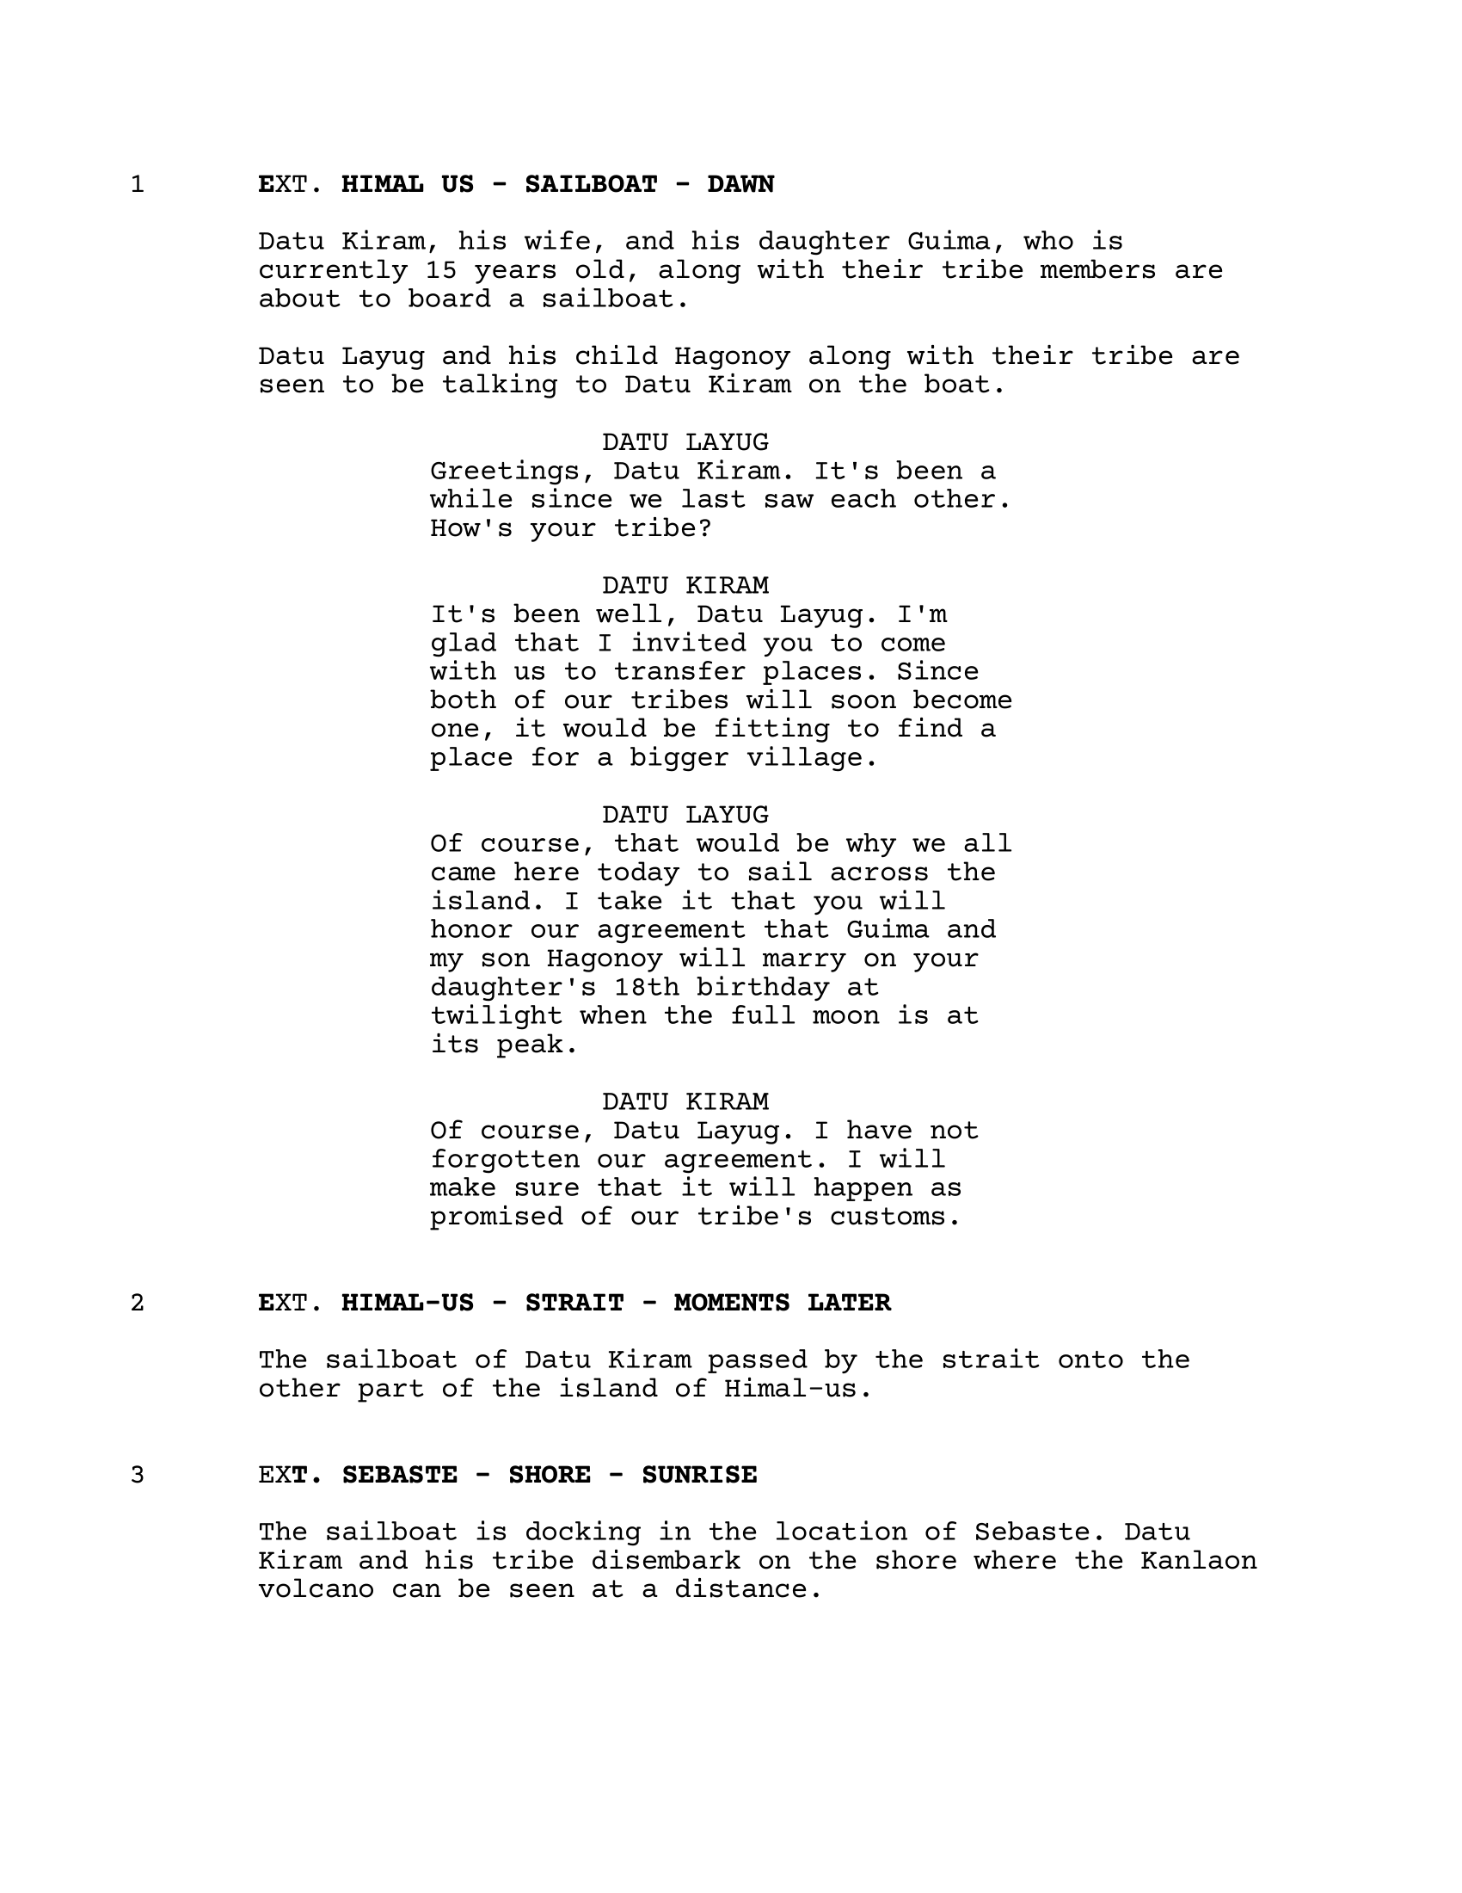

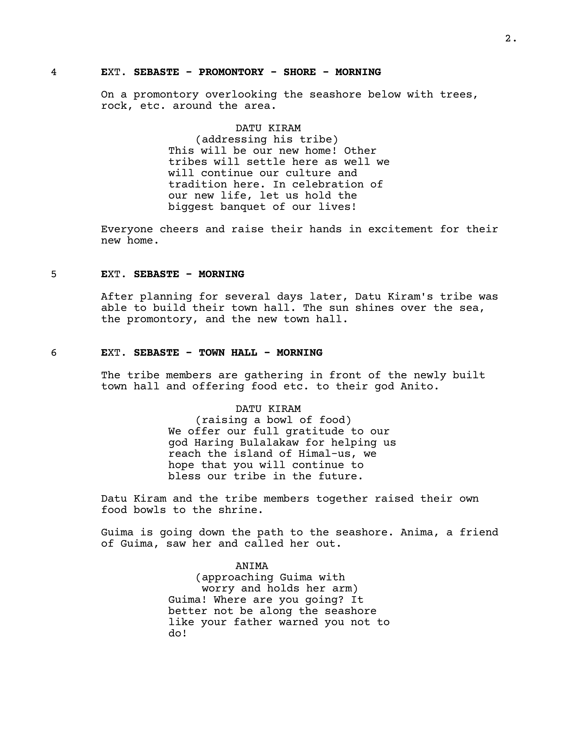

Appendix T

Survey Questionnaire

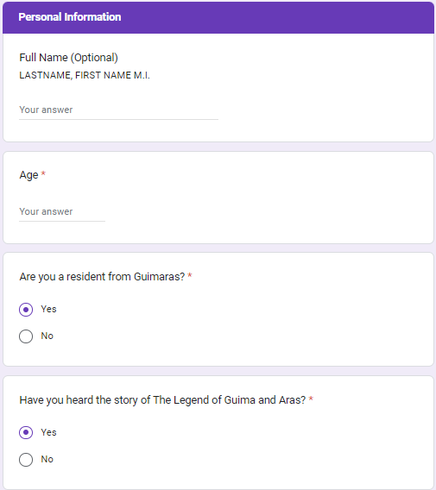

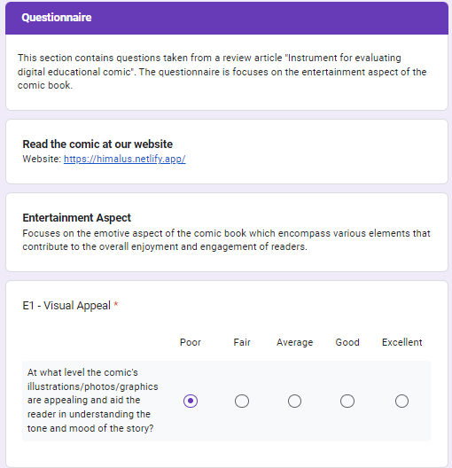

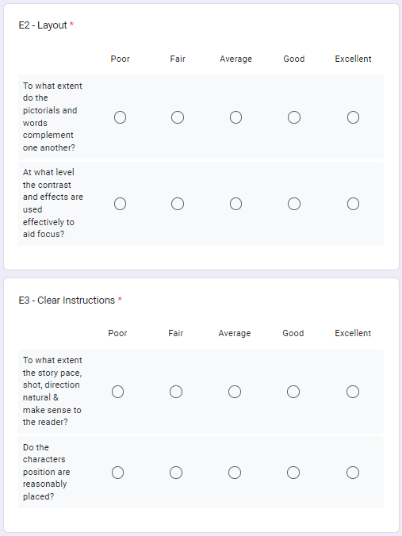



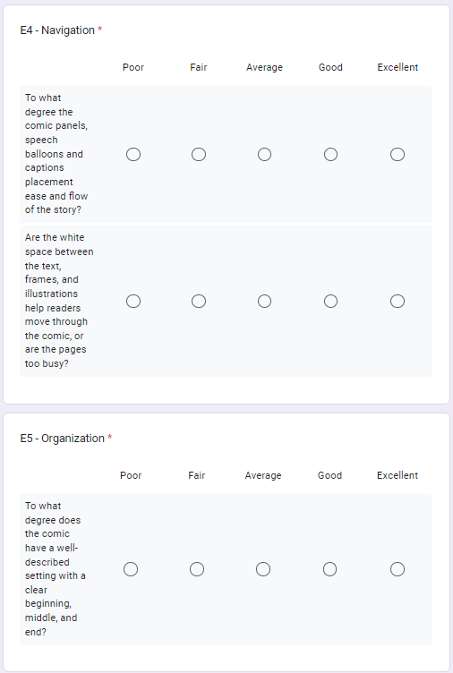

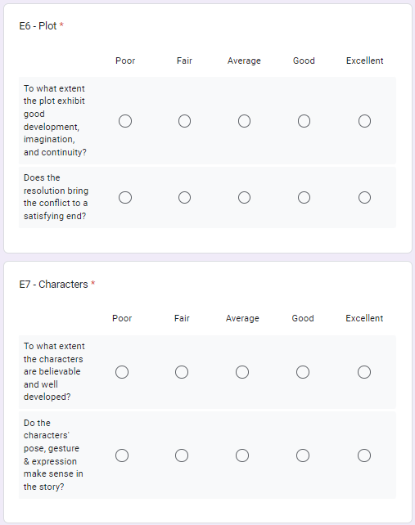



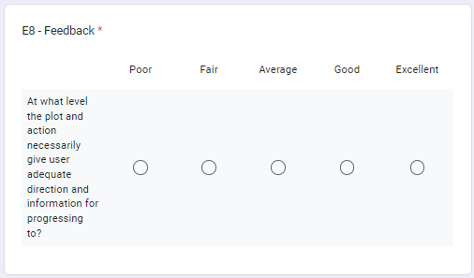

Appendix U

Disclaimer

This research project and its corresponding documentation entitled “Himal-us: A Multimedia Based Comic Book on The Legend of Guima and Aras” is submitted to the College of Information and Communications Technology, West Visayas State University, in partial fulfillment of the requirements for the degree, Bachelor of Science in Entertainment and Multimedia Computing. It is the product of our own work, except where indicated text.

We hereby grant the College of Information and Communications Technology permission to freely use, publish in local or international journal/conferences, reproduce, or distribute publicly the paper and electronic copies of this software project and its corresponding documentation in whole or in part, provided that we are acknowledged.

JM G. Delgado

Christ Mae E. Diaz

Erjohn S. Fernandez

Veronica E. Lumahan

June 2024